第一章

1. 编写程序，从键盘输入两个整数，计算它们的和并在屏幕上输出。

程序运行示例：

Please input two numbers:

45 67

The sum is 112.

#include <stdio.h>

int main()

{

    int x, y, sum;

    printf("Please input two numbers:\n");

scanf("%d%d", &x, &y);

    sum = x + y;

    printf("The sum is %d.\n", sum);

    return 0;

}

以下首先介绍下载并安装CodeBlocks的基本过程。

codeblocks可以从网站<https://www.codeblocks.org>免费下载。

【1】首先在浏览器地址栏里输入网址<https://www.codeblocks.org>，会看到如下图所示的页面：



【2】点击页面左侧的Downloads超级链接，跳转到如下页面：



【3】点击Download the binary release超级链接，跳转如下下载页面：

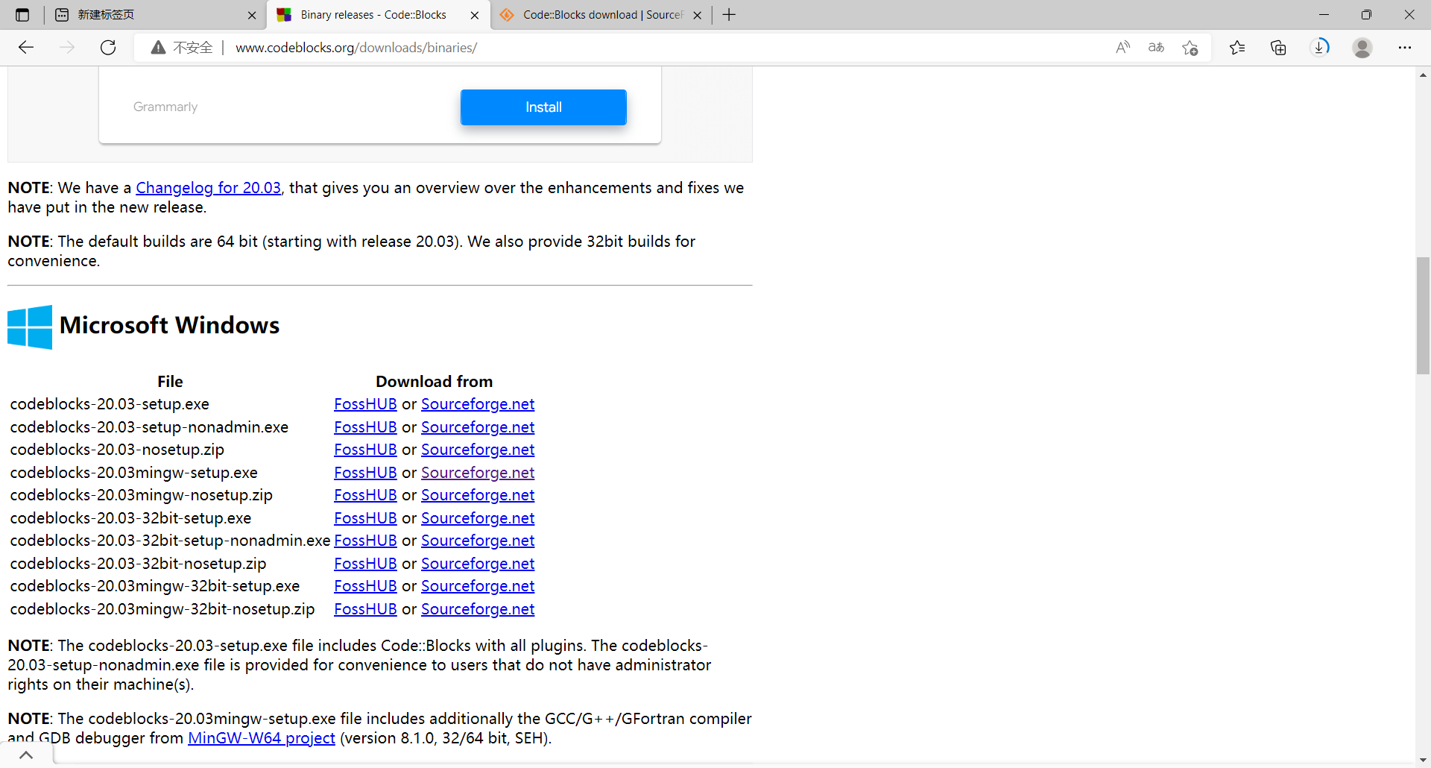

【4】点击第4个File codeblocks-20.03mingw-setup.exe后面的超级链接FossHUB，将安装文件codeblocks-20.03mingw-setup.exe下载本地计算机。

【5】用鼠标双击安装文件codeblocks-20.03mingw-setup.exe，弹出如下对话框：

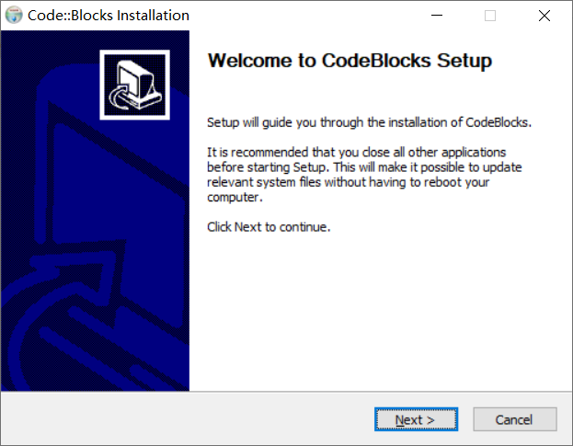

【6】点击“Next”按钮，弹出如下对话框：



【7】点击“I Agree”按钮，弹出如下对话框：



【8】点击“Next“按钮，弹出如下对话框：



【9】记住我们的安装目录为“C:\Program Files\CodeBlocks“，点击”Install”按钮，等待安装完成，弹出如下对话框：

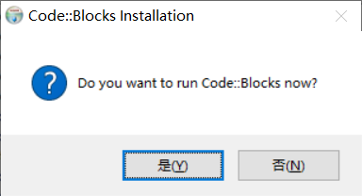

【10】点击“是(Y)”按钮，弹出如下对话框：

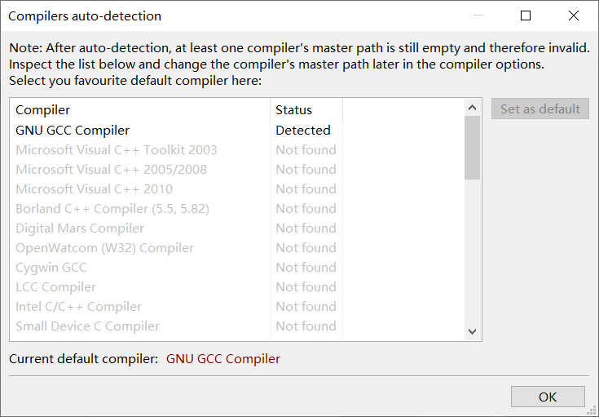

【11】点击“OK”按钮，弹出如下对话框：

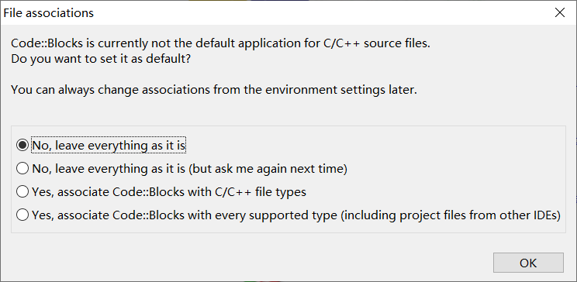

【12】点击“OK”按钮，我们就可以在CodeBlocks里编写编译并运行程序了。关闭CodeBlocks之后，每次可以通过双击桌面上的CodeBlocks图标打开CodeBlocks。

以下介绍运用codeblocks编写、编译和运行程序的基本过程。

1. 双击桌面上的CodeBlocks图标，启动CodeBlocks，如下图所示：

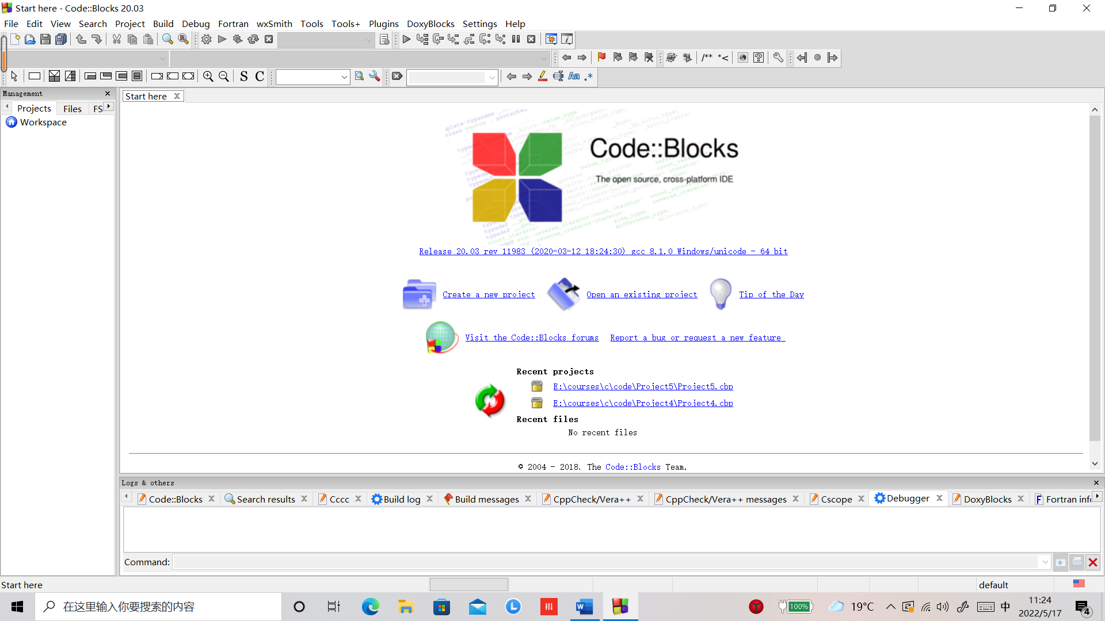

【2】点击File->New->Project…，如下图所示：

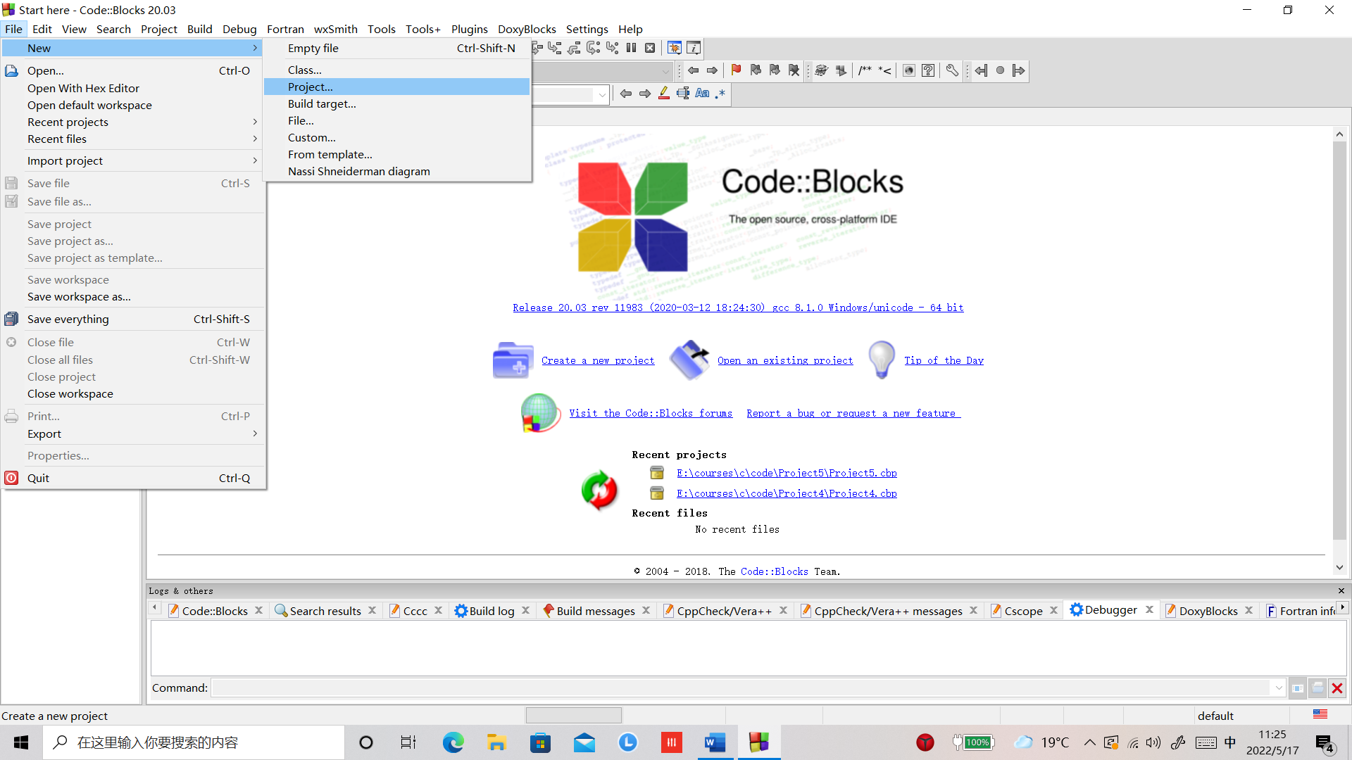

之后会显示如下的对话框：



1. 选择“Console application”，点击“Go”按钮，得到如下对话框：



1. 点击“Next”按钮，得到如下对话框：

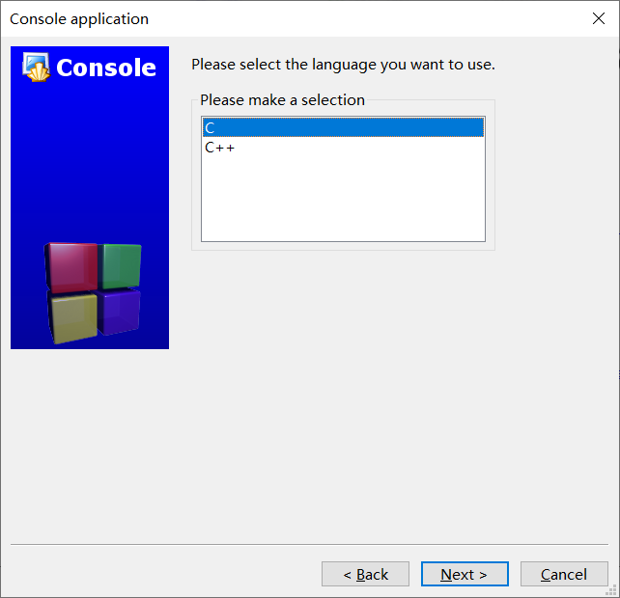

1. 选择“C”，点击”Next”按钮，显示如下对话框：

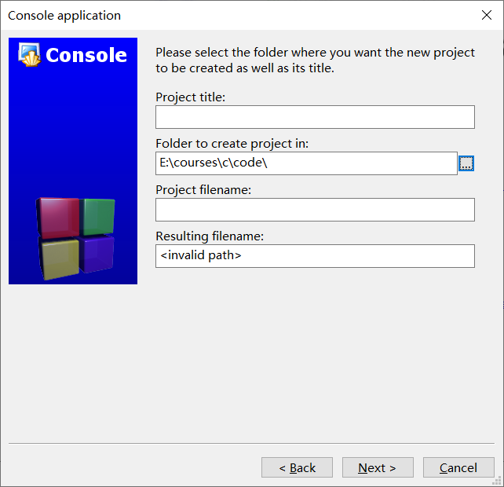

1. 点击“Folder to create project in:”文本框右边的“…”按钮，选择我们要建立的Project所在的目录。注意：我们要建立的Project所在的目录中不能出现中文或空格，例如，“C:\lian xi”或者”C:\练习”，这会导致CodeBlocks的调式功能失效。在“Project tile”中输入我们要建立的Project的名字，同样的，为Project取的名字中不能出现中文或空格，这也会导致CodeBlocks的调试功能失效。如下图所示：

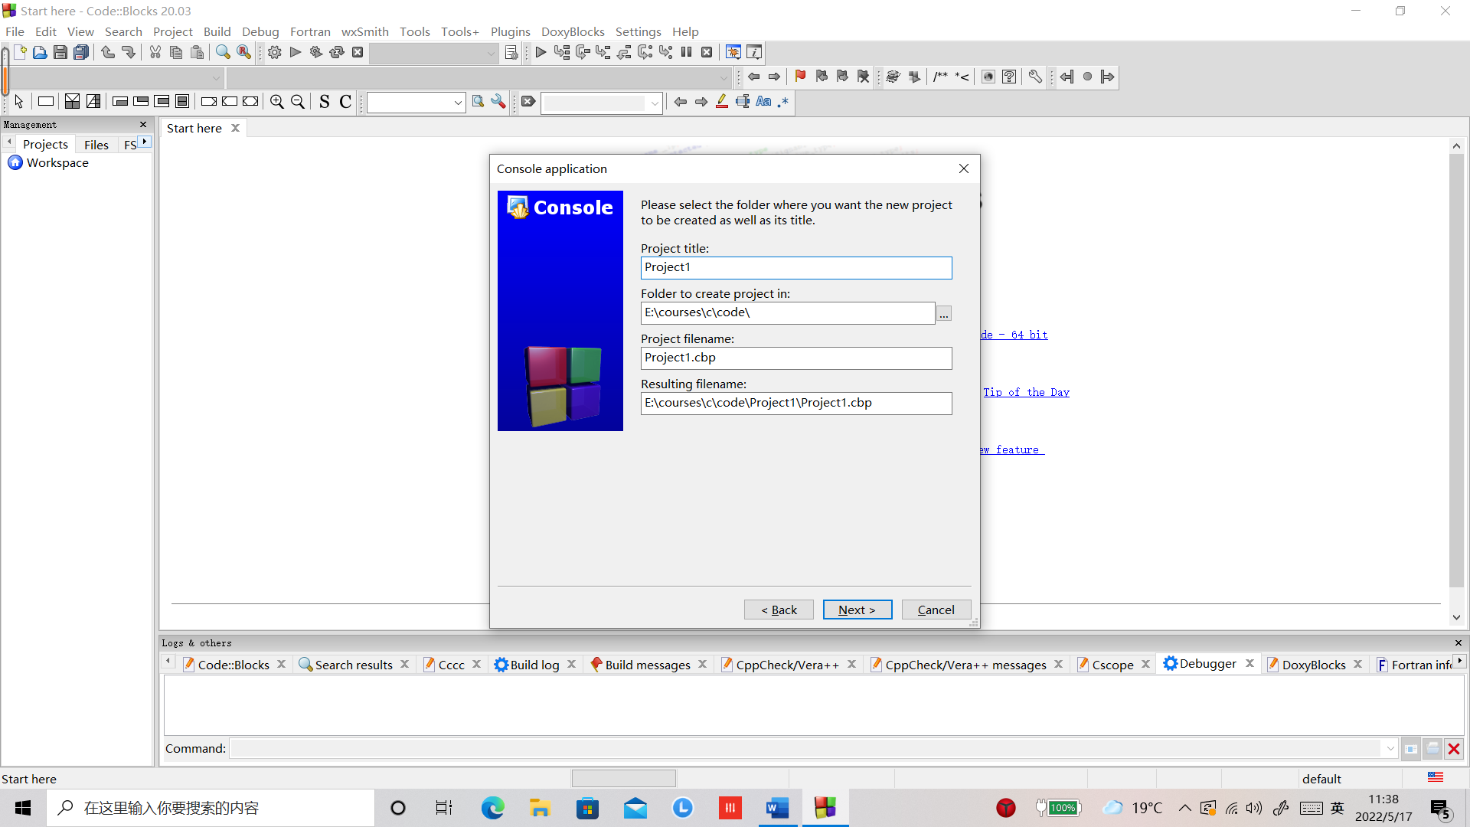

1. 点击“Next”按钮，得到如下对话框：

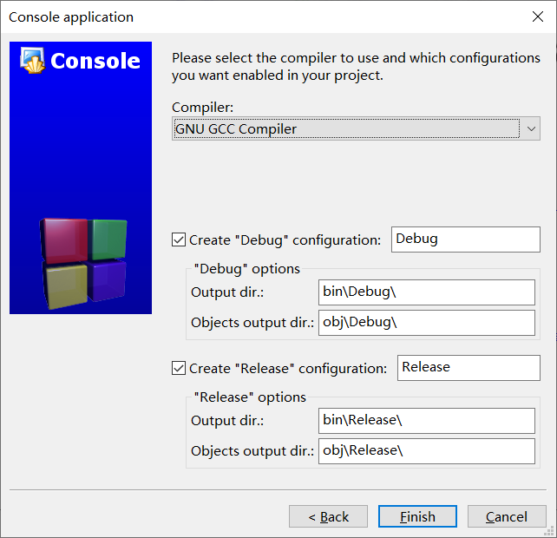

1. 点击“Fininish”按钮，CodeBlocks就为我们建好了Project，如下图所示：

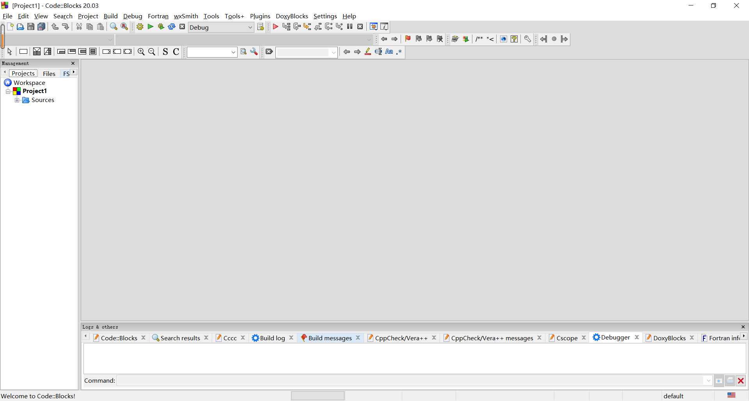

1. 点击左侧“Sources”左侧的“+”号，点击“main.c”，如下图所示：

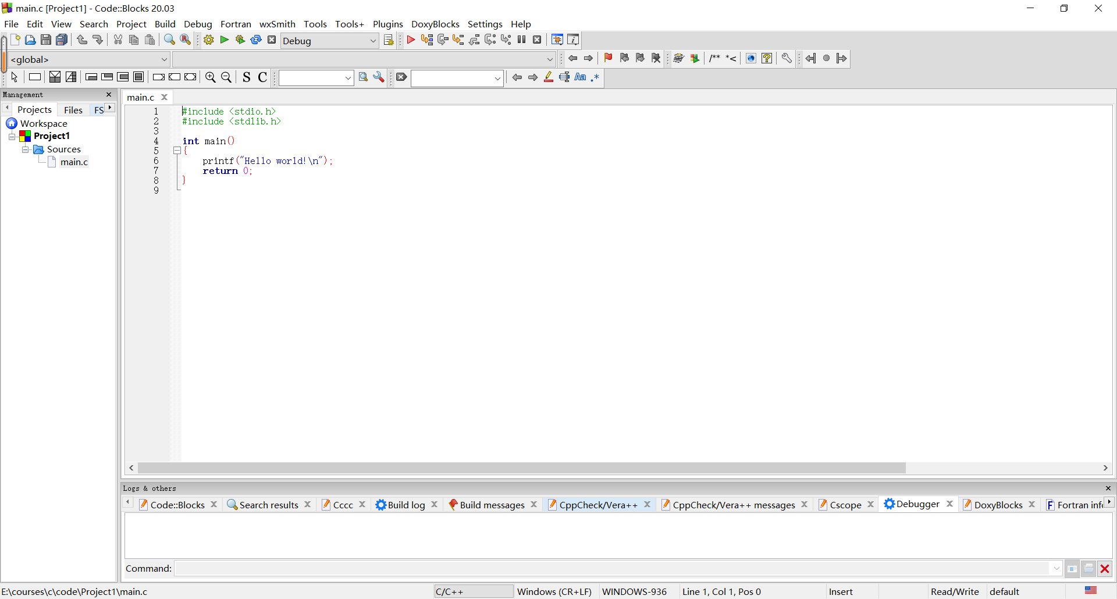

1. 在编辑器中输入如下代码：

#include <stdio.h>

int main()

{

    int x, y, sum;

    printf("Please input two numbers:\n");

    scanf("%d%d", &x, &y);

    sum = x + y;

    printf("The sum is %d.\n", sum);

    return 0;

}

如下图所示：

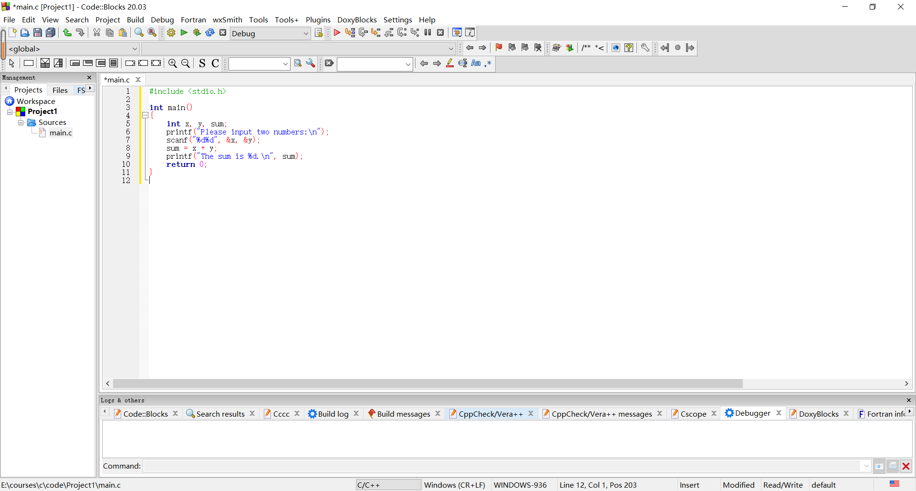

1. 用鼠标点击“Build and Run”按钮，如下图所示：

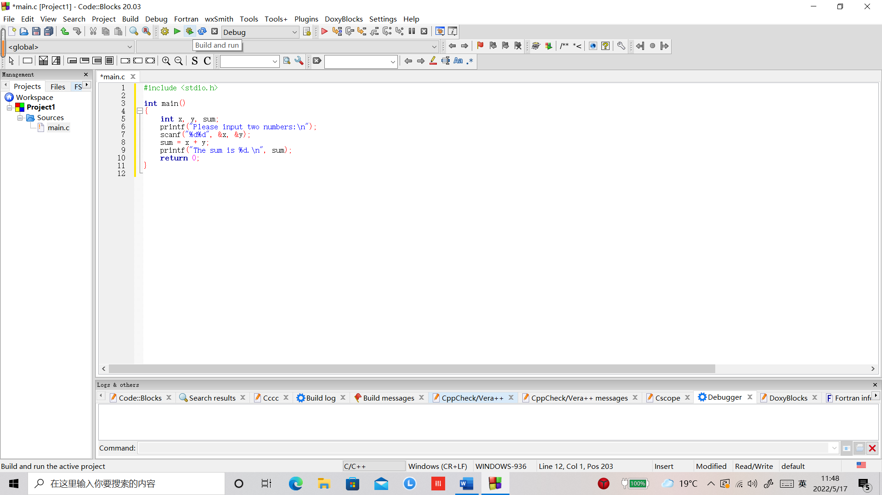

弹出如下对话框：

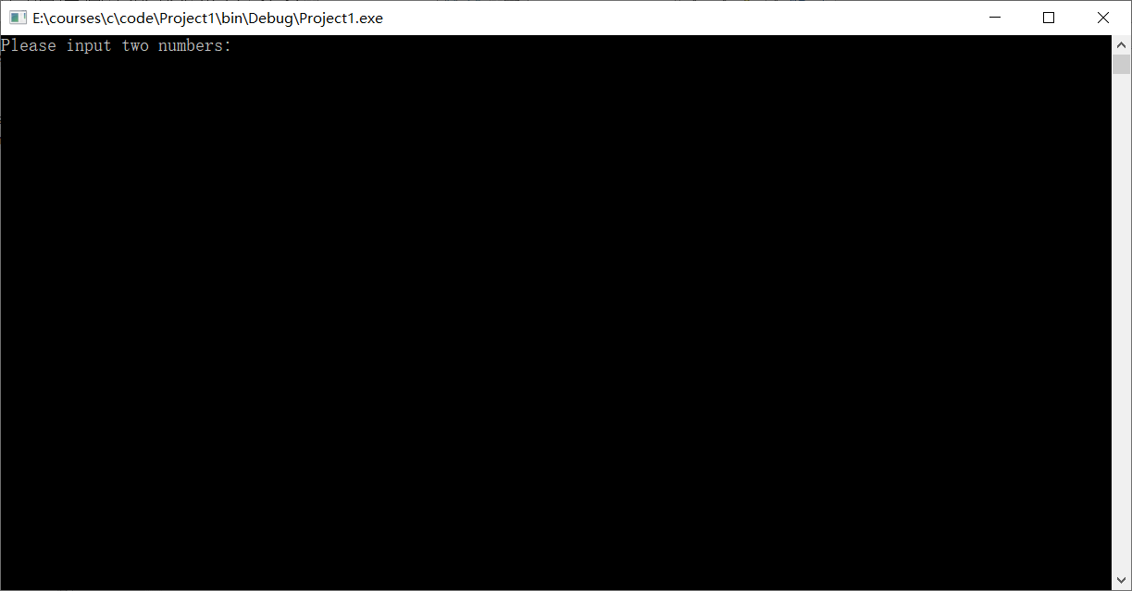

1. 输入“45 67”，敲回车，得到如下图所示的运行结果：

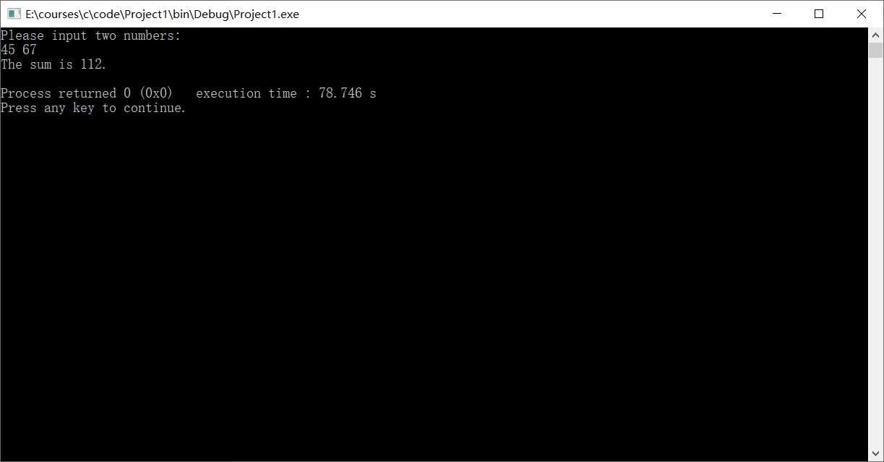

我们的程序运行成功了！

接下来我们尝试一下CodeBlocks的调试功能。

1. 在main函数的第一行代码的左侧用鼠标单击，会看到一个小红点，表示我们设置了一个断点，如下图所示：

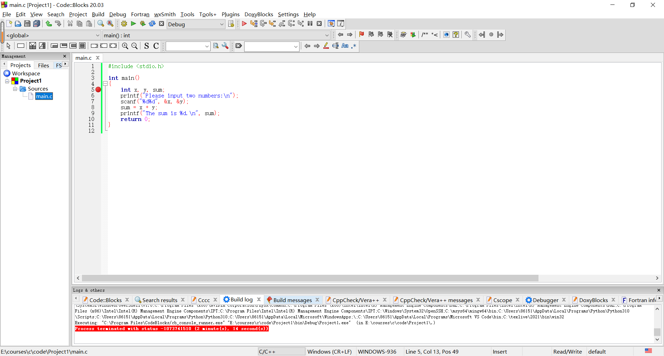

1. 点击“Debug/Continue”按钮（红色的小三角），如下图所示：

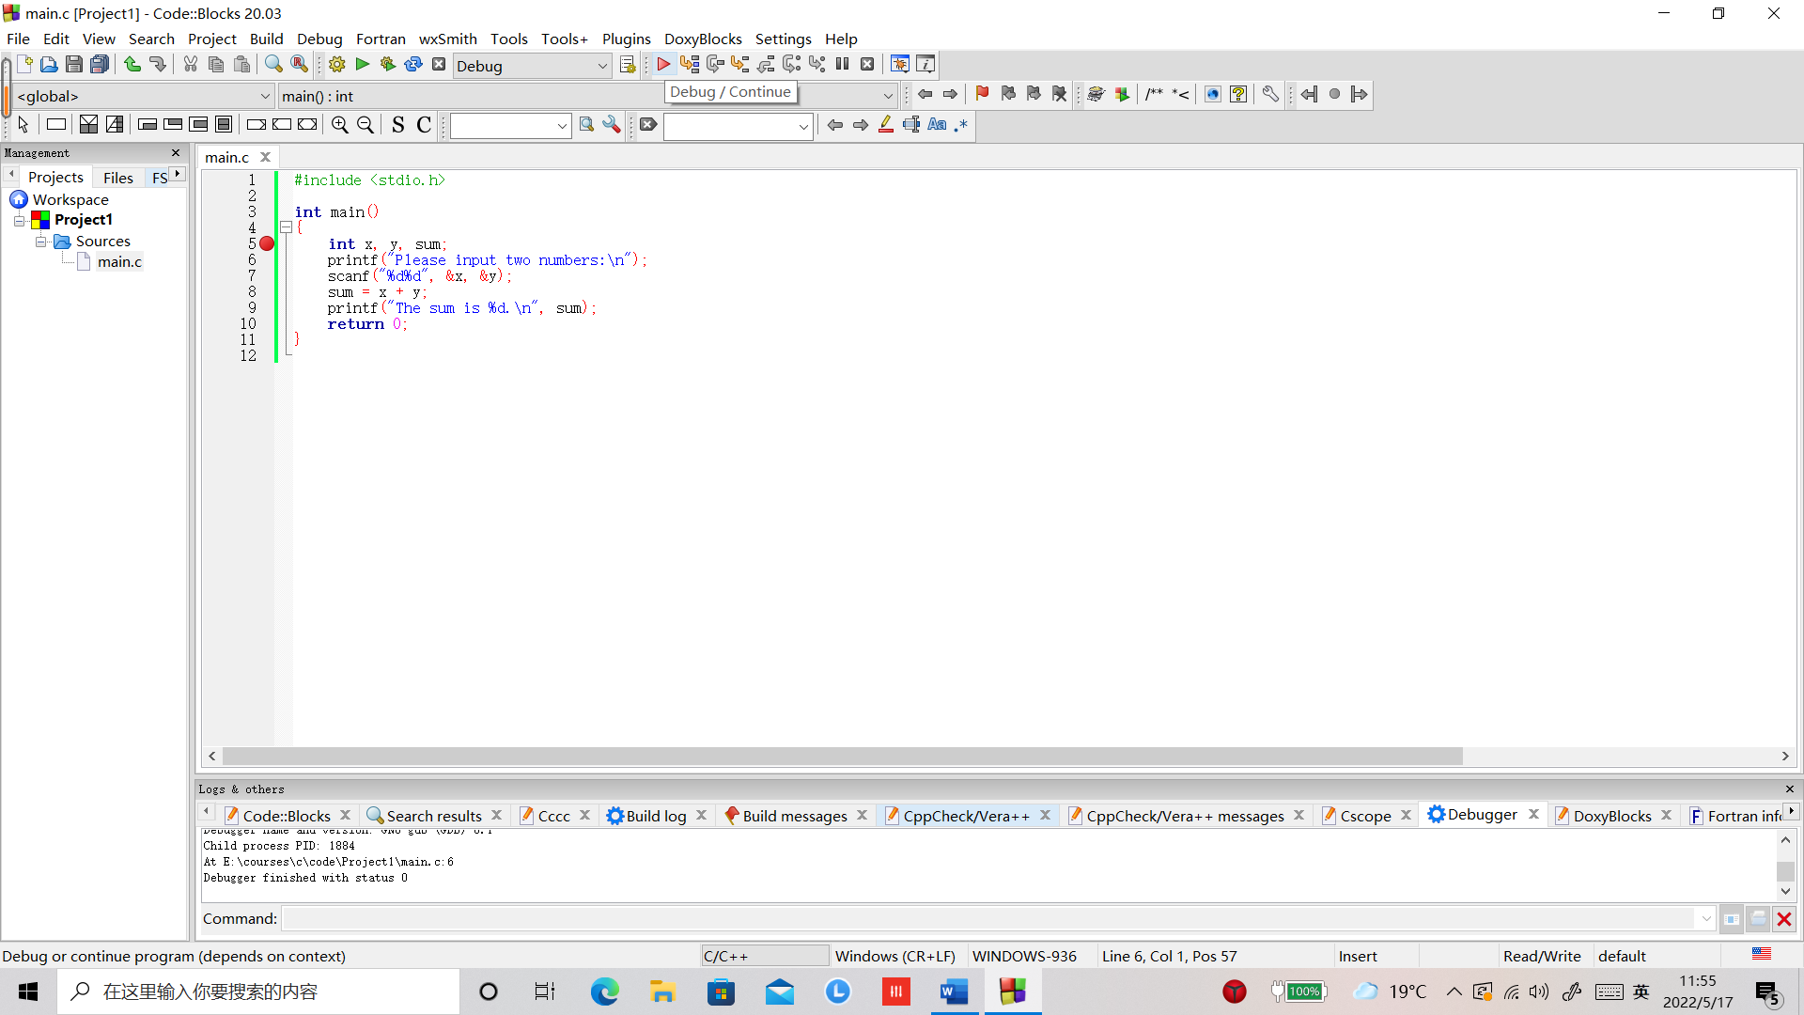

程序会执行到断点处停止运行，在代码的左侧会看到一个黄色的小三角，指示下一步要运行的代码，如下图所示：

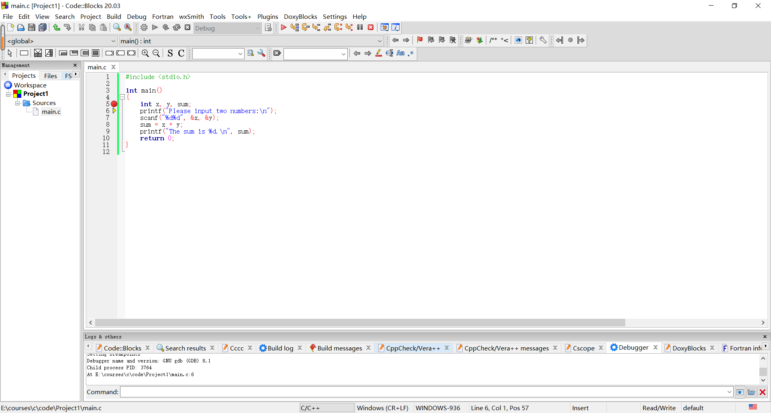

1. 点击“Next line”按钮，可以单步运行代码，如下图所示：

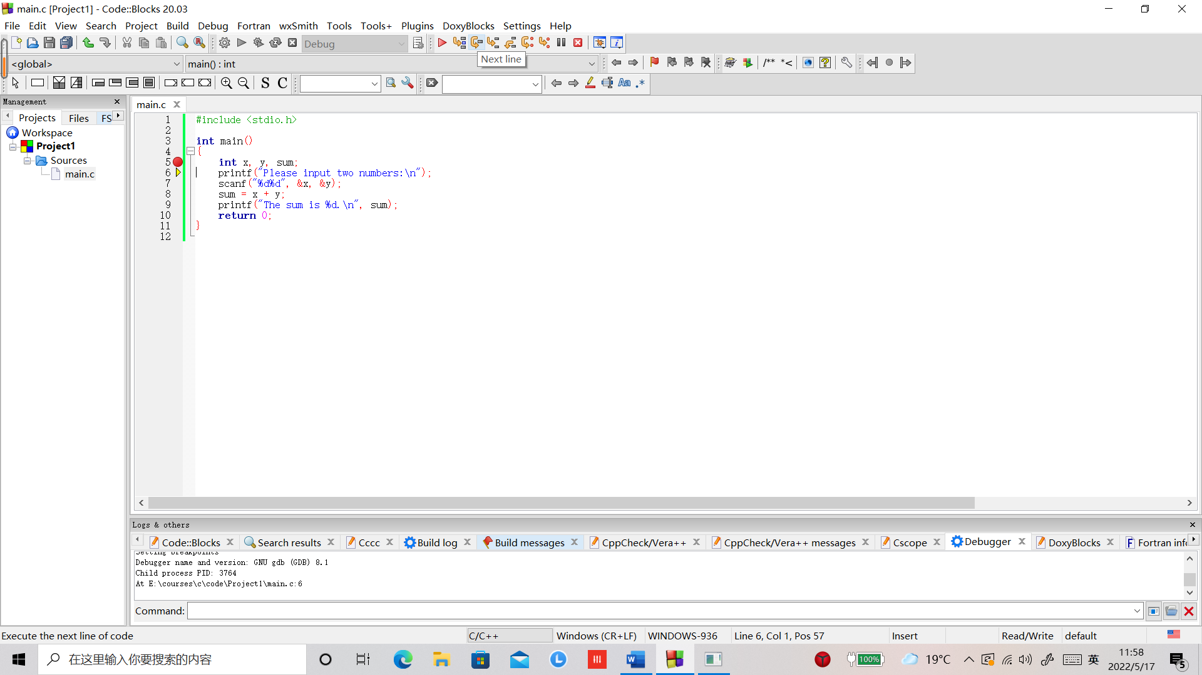

1. 点击电脑屏幕下方命令提示符的按钮，弹出命令提示符窗口，可以看到程序运行的输出，如下图所示：

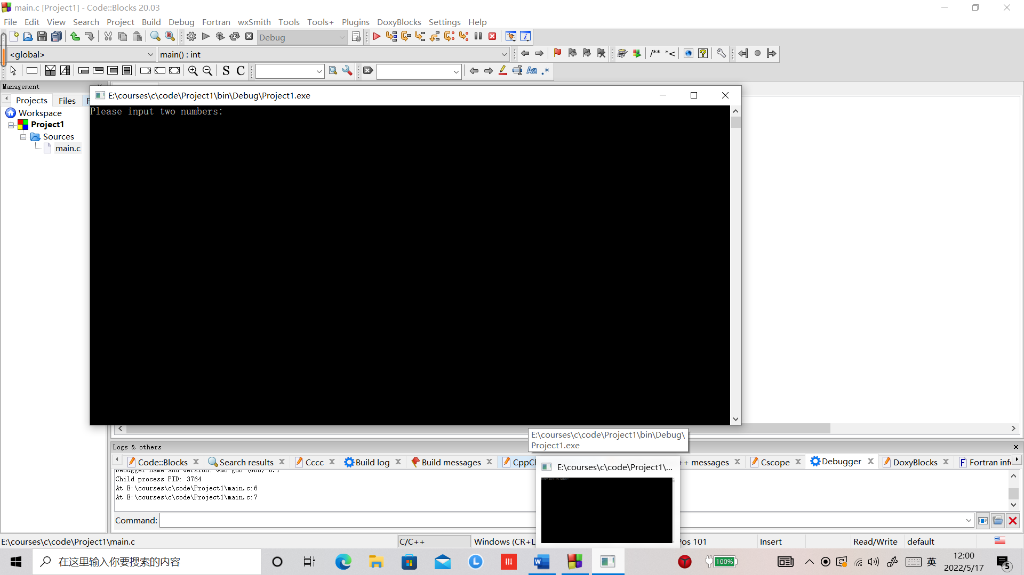

1. 点击电脑屏幕下方命令提示符的按钮，可以随时显示或者隐藏命令提示符窗口。
2. 点击“Next line”按钮，程序会执行代码“scanf("%d%d", &x, &y);”，等待从键盘输入。点击电脑屏幕下方命令提示符的按钮，显示命令提示符窗口，输入输入“45 67”，敲回车，再次点击电脑屏幕下方命令提示符的按钮，隐藏命令提示符窗口。

【18】点击“Debugging windows”按钮（小虫子），如下图所示：

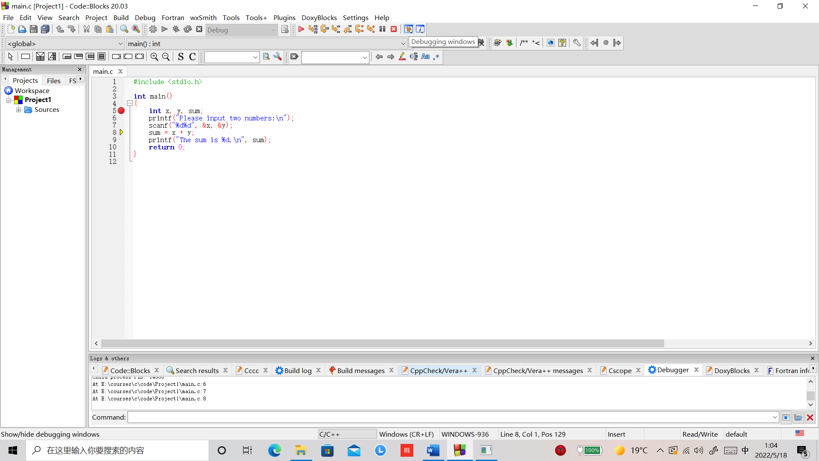

我们会看到一个弹出菜单，如下图所示：

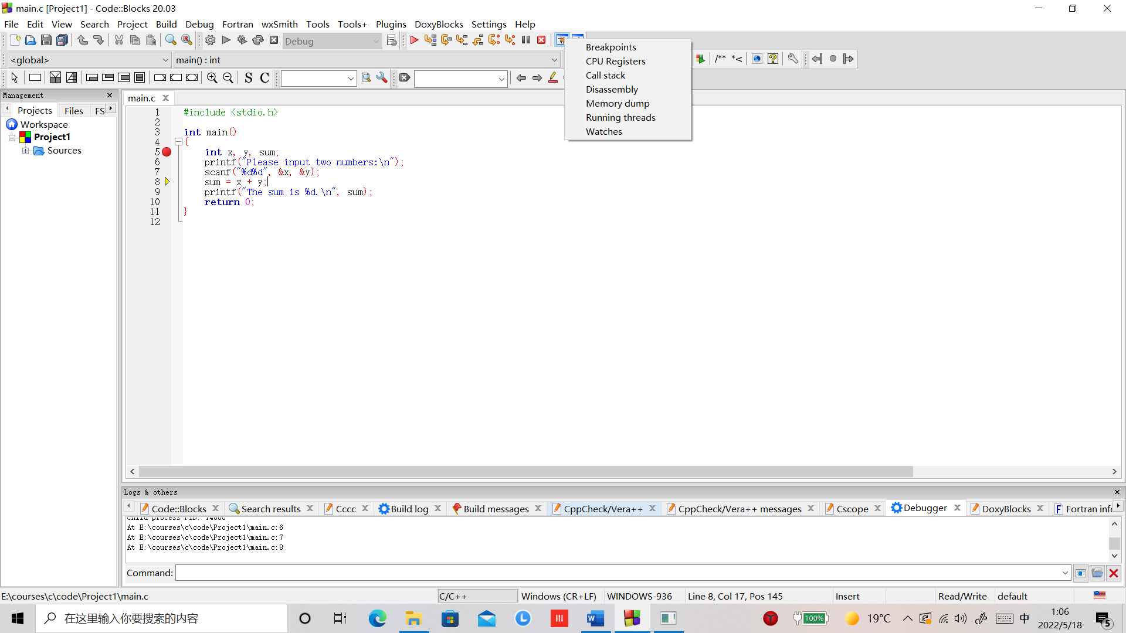

1. 点击“Watches”菜单项，弹出一个”Watches”窗口，在其中可以查看程序中各个变量的值，如下图所示：

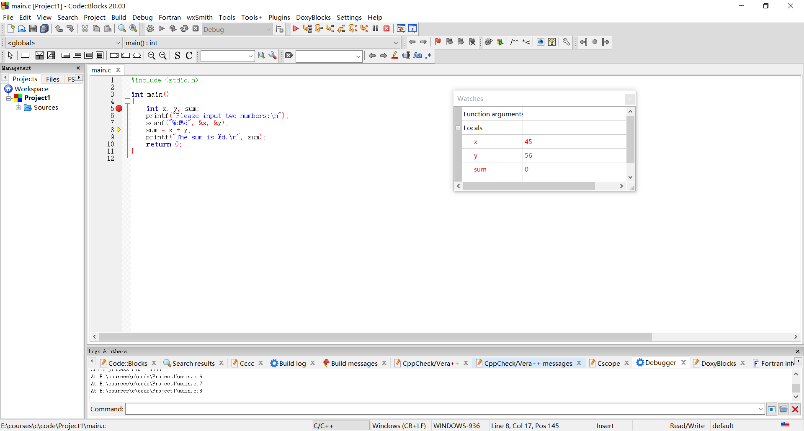

1. 点击““Next line”按钮，可以看到“Watches“窗口中”sum”变量的值变成了101。
2. 依次点击“Next line”按钮，可以随时在“Watches”窗口中查看程序中各变量的值，在“命令提示符窗口”中查看程序的运行结果。如果发现代码中的错误，可以点击“Stop debugger”终止程序的运行，修改代码中的错误，再次调试运行，直至程序运行正确。

如果我们关闭了CodeBlocks，应该怎么打开以前的项目呢？

1. 双击桌面上的CodeBlocks图标，启动CodeBlocks，如下图所示：



1. 点击“File->Open…”，如下图所示：

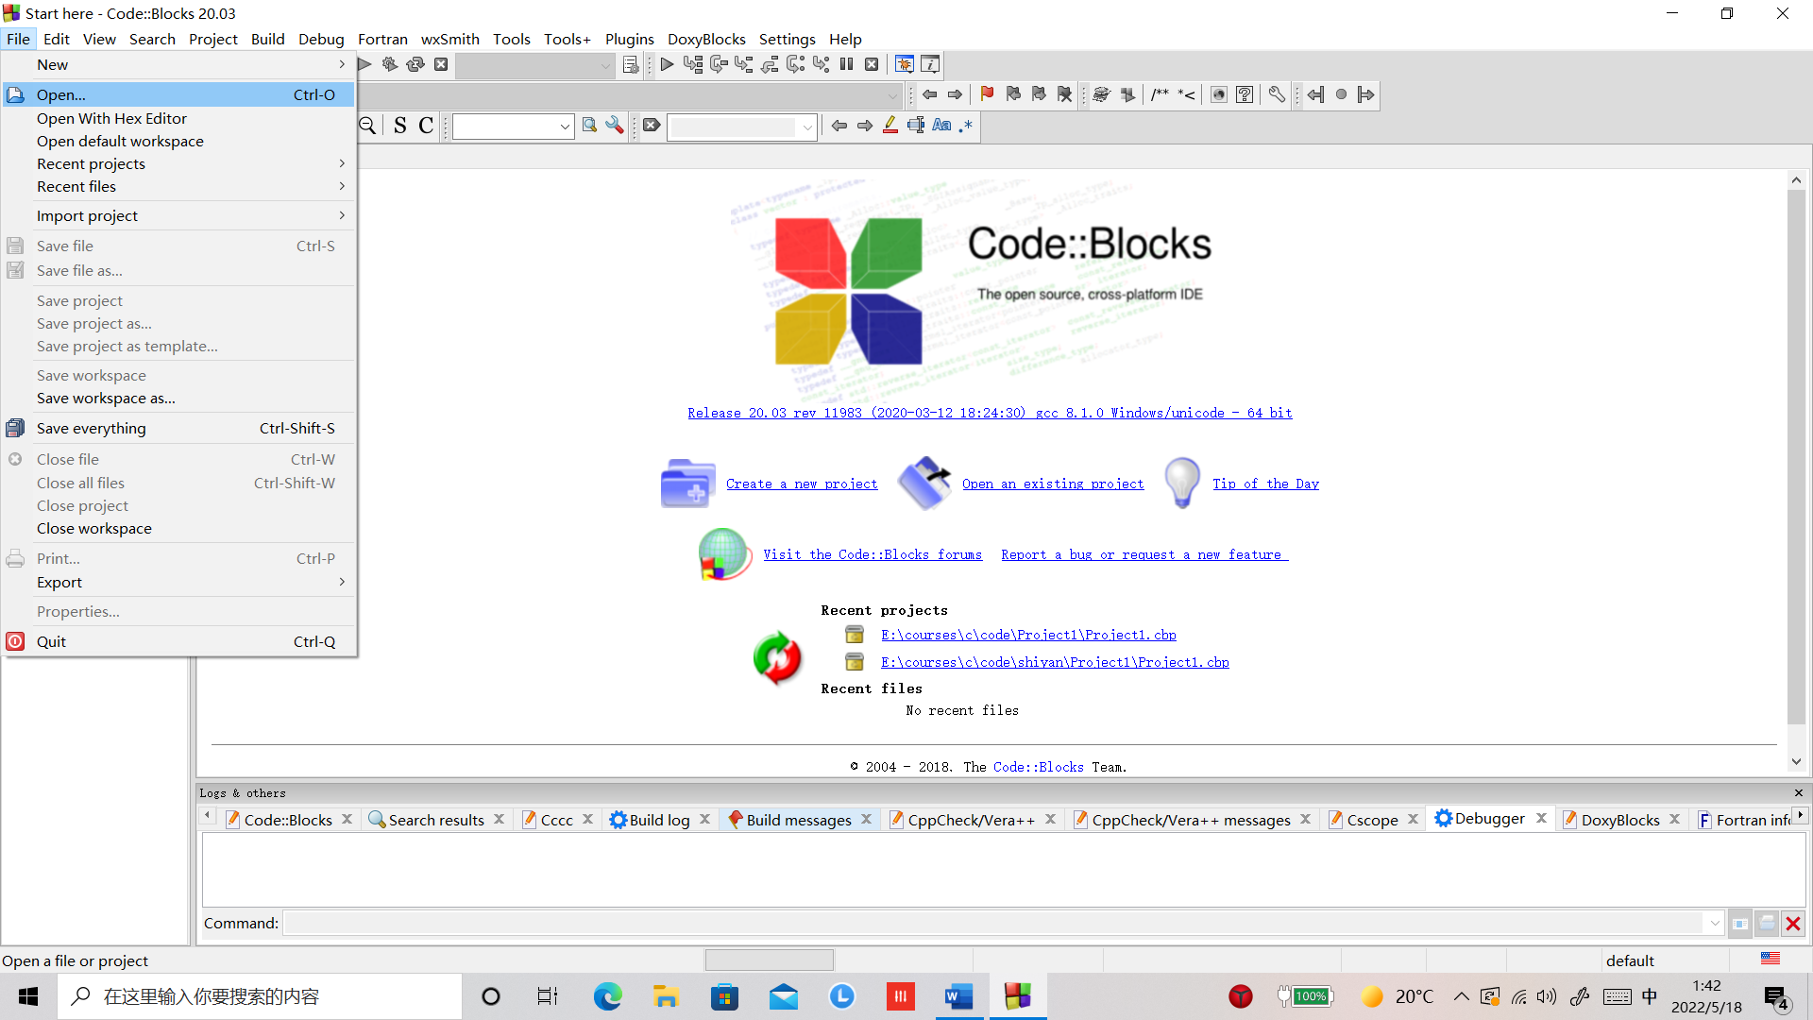

1. 选择以前建立的Project所在的目录，例如“E:\courses\c\code\Project1”，（记住Project建在哪个目录下是不是很重要？），选择打开.cbp文件（注意这里需要选择.cpb文件，而不是.c文件），如下图所示：

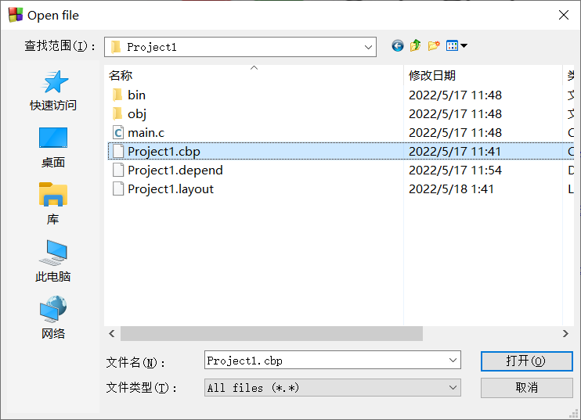

1. 点击“打开”按钮，就可以打开以前的Project，继续编写、编译、调试、运行代码了。

事实上，CodeBlocks是通过运行gcc命令来编译C源程序的。gcc命令是一个可执行文件gcc.exe，位于CodeBlocks的安装目录下MinGW\bin子目录下，例如C:\Program Files\CodeBlocks\MinGW\bin目录下。要想在Windows命令提示符下运行gcc命令，需要首先将gcc命令所在的文件目录添加到Windows系统的PATH环境变量中，可以按如下步骤进行：

1. 在Windows开始菜单右侧的文本框中输入“查看高级系统设置“，如下图所示：



弹出如下对话框：



1. 点击“环境变量“按钮，弹出如下对话框：



1. 用鼠标点击“系统变量“中的”Path“环境变量，如下图所示：



1. 点击“编辑“按钮，弹出如下对话框：

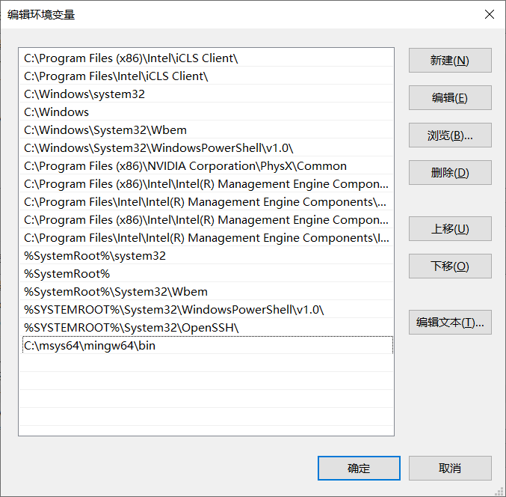

1. 从文件资源管理器中复制gcc.exe所在的文件目录，如下图所示：

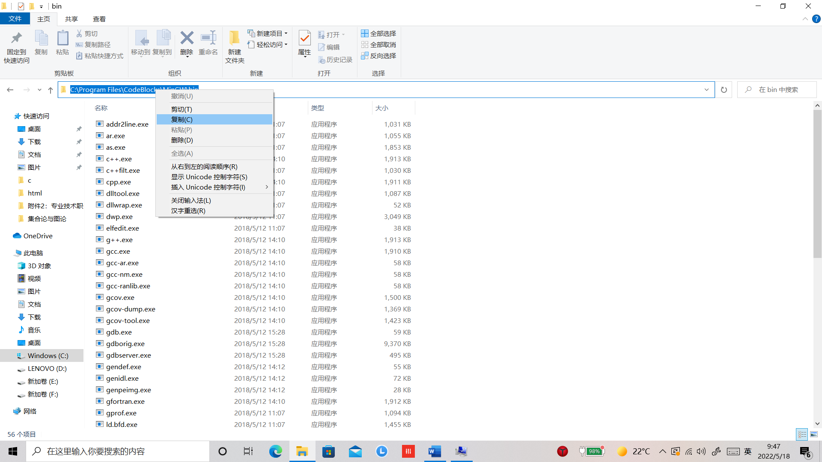

1. 在第4步弹出的对话框中点击“新建”按钮，在最后一行中粘贴刚才复制的gcc.exe所在的文件夹目录，如下图所示：

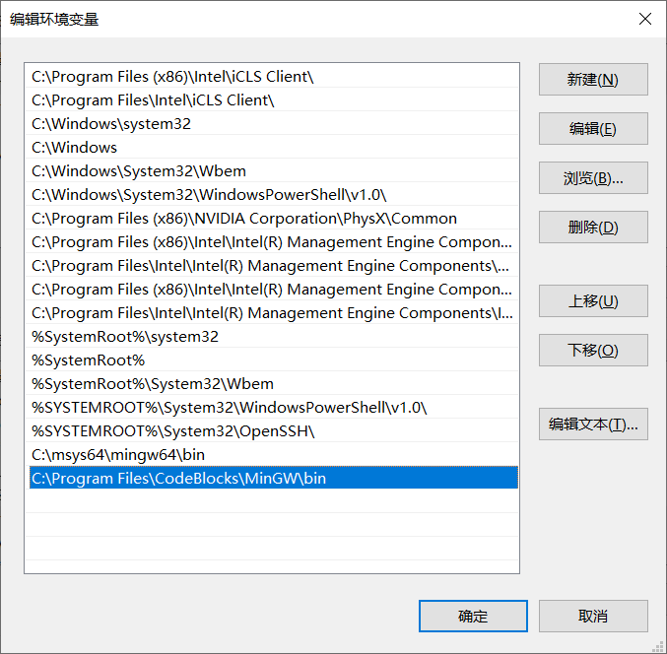

1. 点击“确定”按钮，我们将gcc.exe所在的目录添加到了Path环境变量中。
2. 在Windows开始菜单右侧的文本框中输入“cmd“，如下图所示：



1. 点击“命令提示符”按钮，弹出“命令提示符对话框”，如下图所示：

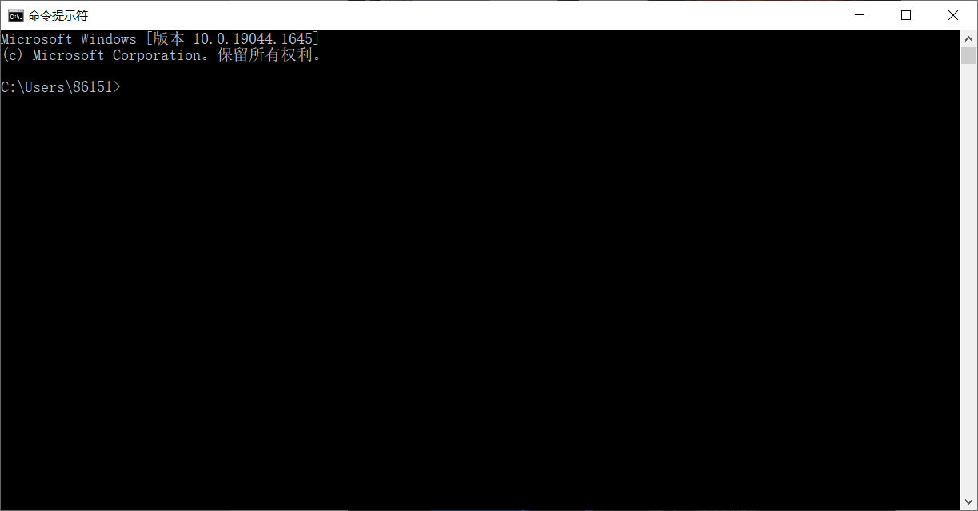

1. 输入如下命令转到我们编辑的C源代码所在的文件夹目录：

C:\Users\86151>e:

E:\>cd courses

E:\courses>cd c

E:\courses\c>cd code

E:\courses\c\code>cd Project1

E:\courses\c\code\Project1>dir

驱动器 E 中的卷是 新加卷

卷的序列号是 D485-9386

E:\courses\c\code\Project1 的目录

2022/05/18 01:48 <DIR> .

2022/05/18 01:48 <DIR> ..

2022/05/17 11:48 <DIR> bin

2022/05/17 11:48 203 main.c

2022/05/17 11:48 <DIR> obj

2022/05/17 11:41 1,059 Project1.cbp

2022/05/17 11:54 99 Project1.depend

2022/05/18 01:48 356 Project1.layout

4 个文件 1,717 字节

4 个目录 84,143,431,680 可用字节

在命令提示符下只输入“e:”之后敲回车表示转到e盘，cd命令表示转到指定的目录，dir表示列出当前目录下所有的文件和自目录。

如下图所示：

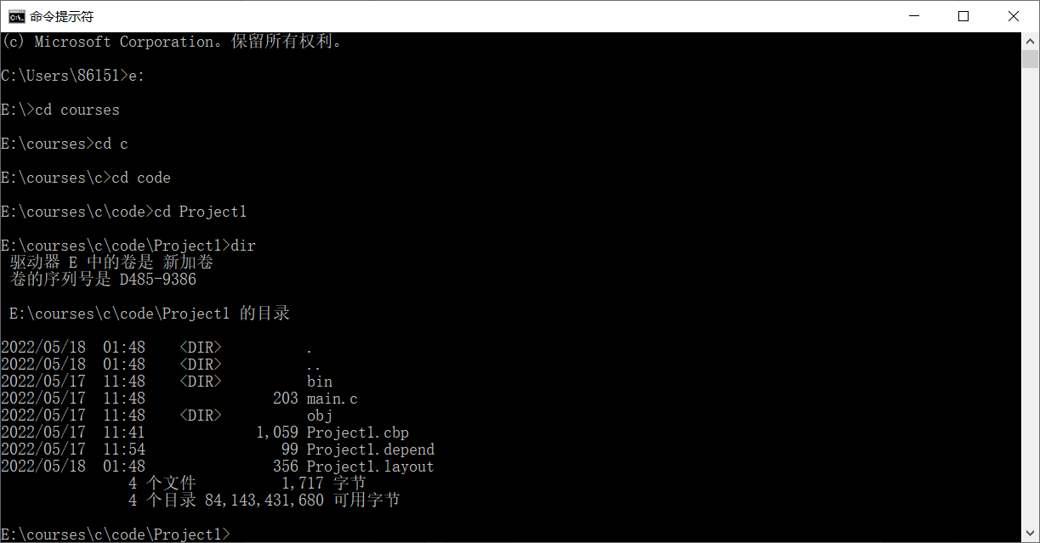

1. 在C源文件main.c所在的目录下，输入如下命令，可以将main.c编译生成可执行文件add.exe:

gcc -o add main.c

如下图所示：

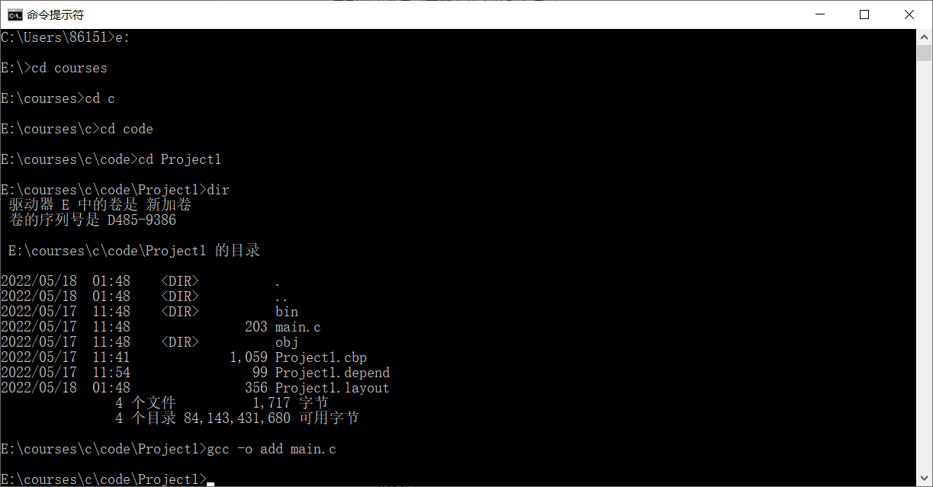

1. 在当前目录下输入dir命令，可以查看生成的add.exe可执行文件。输入.\add可以运行生成的add.exe可执行文件（这里“.”表示当前目录），如下图所示：

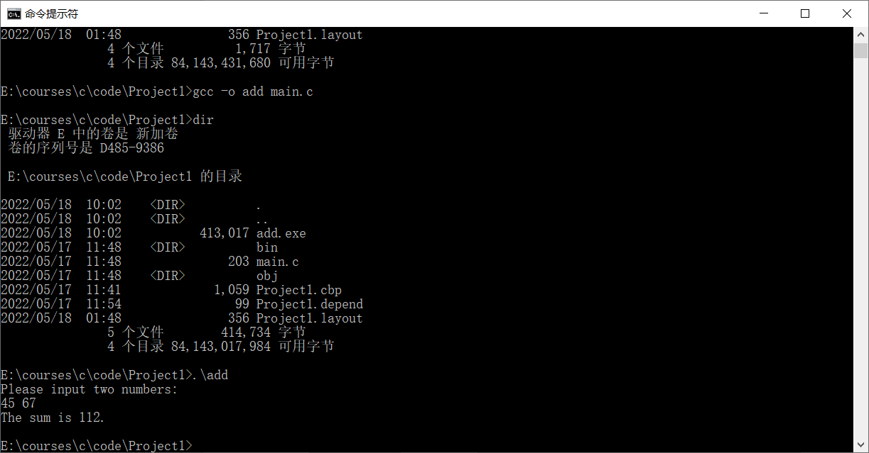

接下来，我们介绍用visual studio code编写、编译和运行程序的基本过程。

首先介绍下载并安装visual studio code的基本过程。

1. 首先在浏览器地址栏里输入网址<https://www.codeblocks.org>，会看到如下图所示的页面：



1. 点击“Download for Windows”，将安装文件VSCodeUserSetup-x64-x.xx.x.exe下载本地计算机。
2. 双击安装文件VSCodeUserSetup-x64-x.xx.x.exe，弹出如下对话框。



1. 选中“我同意此协议”，点击“下一步”按钮，显示如下对话框：



1. 安装目录保留默认值，点击“下一步”按钮，显示如下对话框：



1. 点击“下一步”按钮，显示如下对话框：



1. 选中复选框“创建桌面快捷方式”，如下图所示：



1. 点击“下一步”按钮，弹出如下对话框：



1. 点击“安装”按钮，等待Visual Studio Code安装完成，显示如下对话框：



1. 点击“完成”按钮，Visual Studio Code就安装完成了，首次运行窗口如下：



关闭Visual Studio Code之后，以后可以通过双击桌面上的Visual Studio Code图标运行Visual Studio Code。

以下介绍运用Visual Studio Code编写、编译和运行程序的基本过程。

Visual Studio Code只是一个编辑器，自身并没有编译器，因此需要单独安装编译器。以下假设读者已经安装了CodeBlocks，并按照前述步骤设置了Path环境变量，即在Path环境变量里已经添加了gcc编译器所在的目录。读者也可以参照https://code.visualstudio.com/docs/cpp/config-mingw中介绍的步骤从MSYS2网站（https://www.msys2.org/）下载安装Mingw-w64编译器。

1. 新建一个文件夹，存放我们要编写的文件，例如“E:\courses\c\code\Example1”。
2. 双击桌面上的Visual Studio Code图标运行Visual Studio Code，显示如下窗口：



1. 点击File->Auto Save，这样Visual Studio Code会为我们自动保存编辑的代码。



1. 点击File->Open Folder…，如下图所示：



1. 在弹出的对话框中选择我们想要保存c源文件的文件夹目录，如下图所示：



1. 点击“选择文件夹”按钮，进入Visual Studio Code主界面，如下图所示：



【7】点击“New File”按钮，如下图所示：



1. 输入文件名“add.c“，如下图所示：



【8】在编辑器中输入如下代码：

#include <stdio.h>

int main()

{

int x, y, sum;

printf("Please input two numbers:\n");

scanf("%d%d", &x, &y);

sum = x + y;

printf("The sum is %d.\n", sum);

return 0;

}

如下图所示：

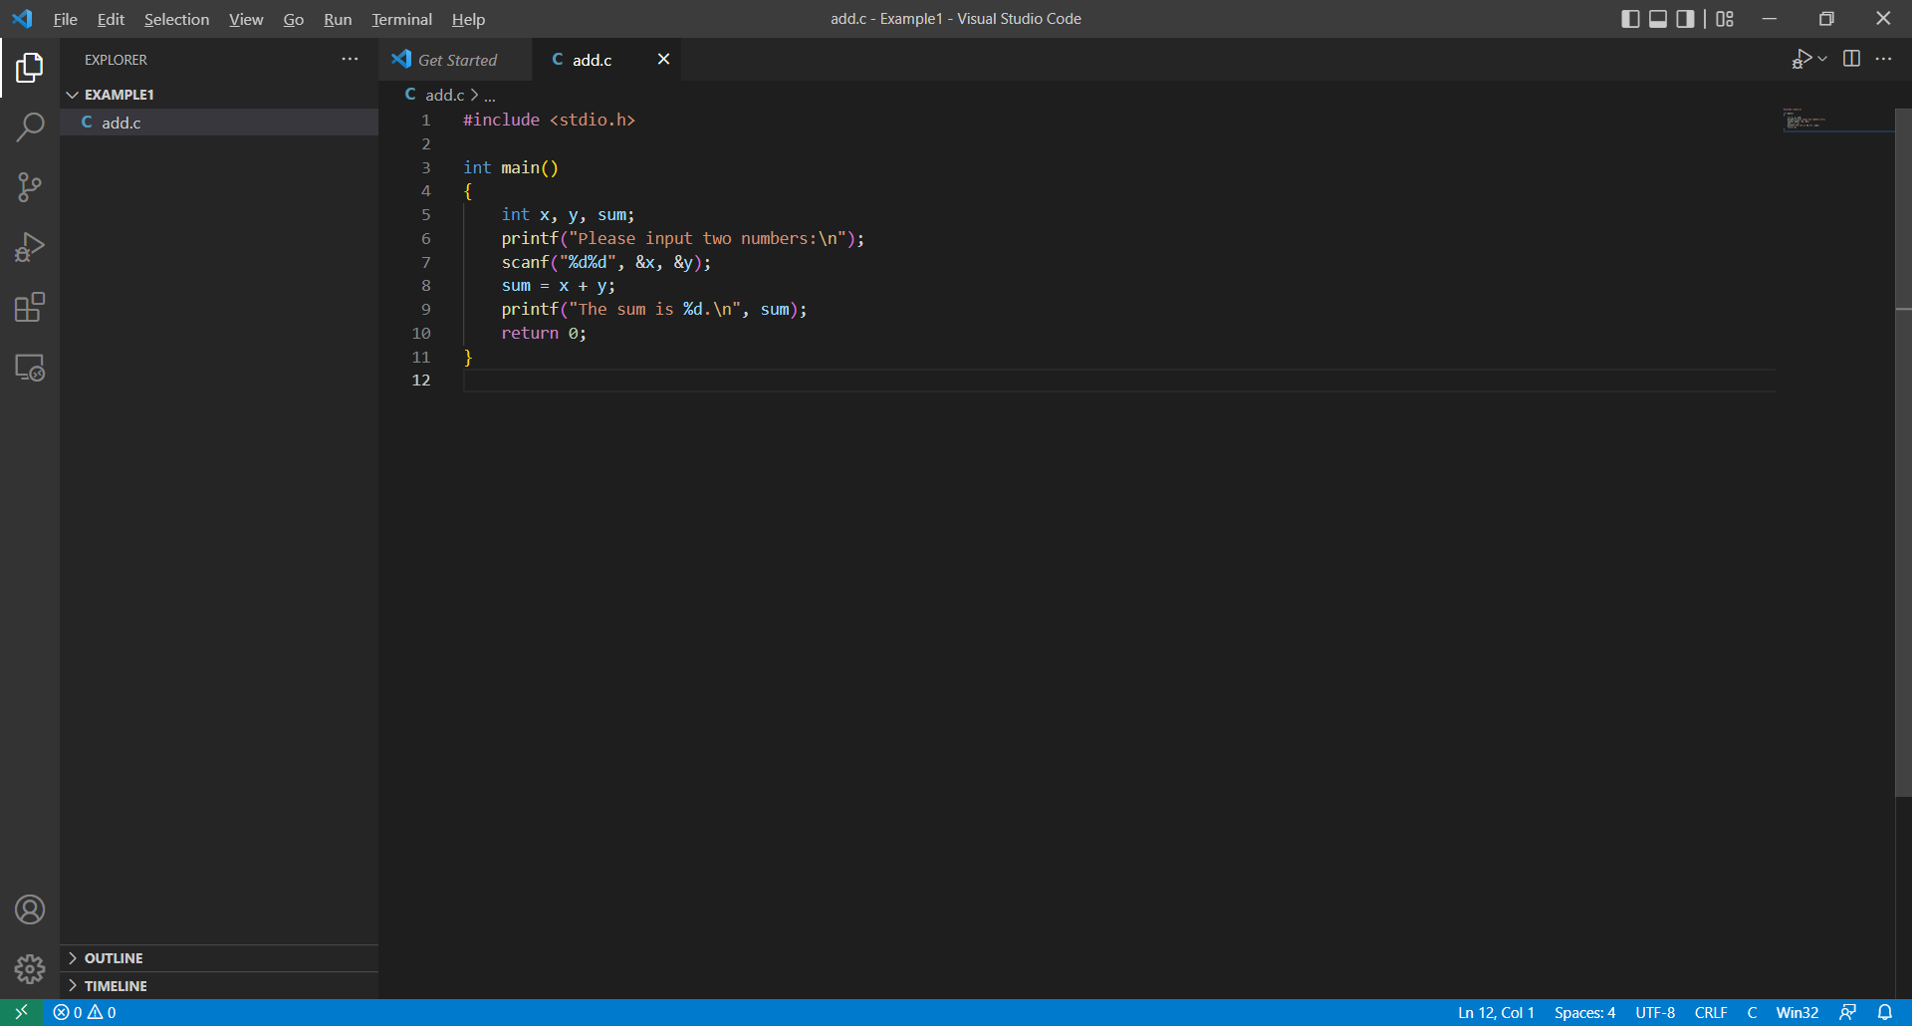

1. 按“Ctrl+`“键，在编辑器下方出现TERMINAL子窗口，如下图所示：

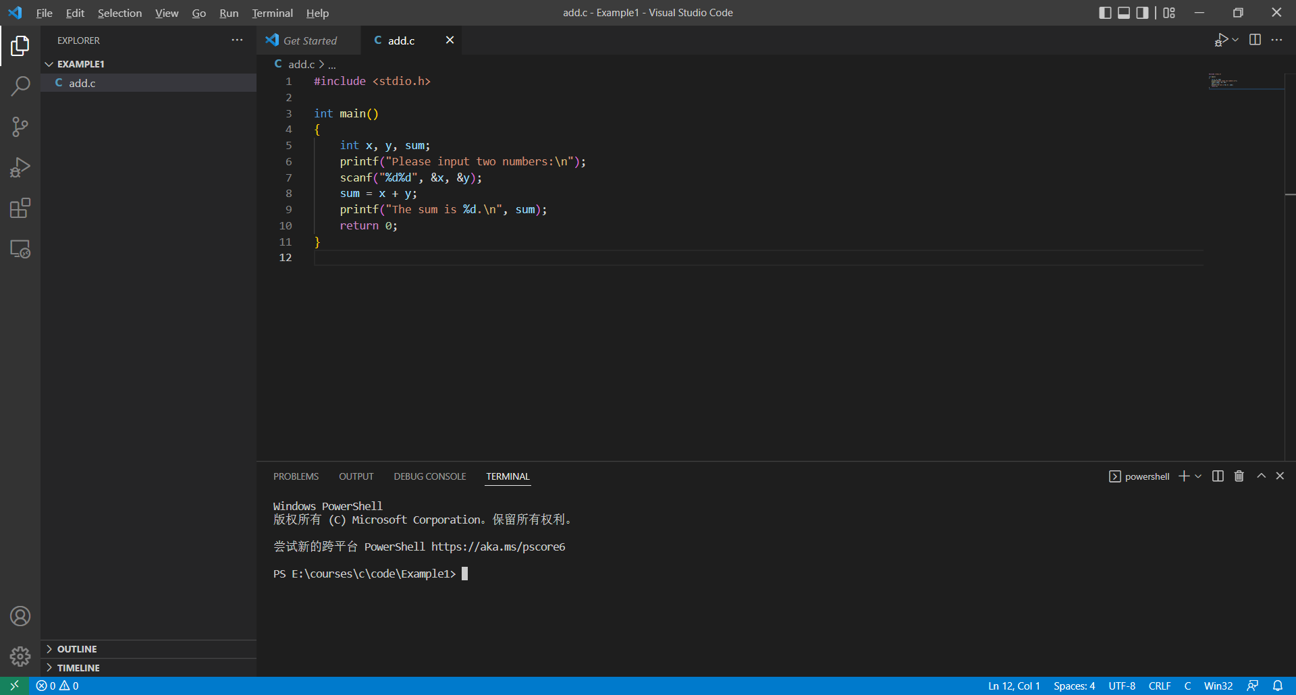

1. 点击“Lunch Profile…“(向下的箭头)，如下图所示：

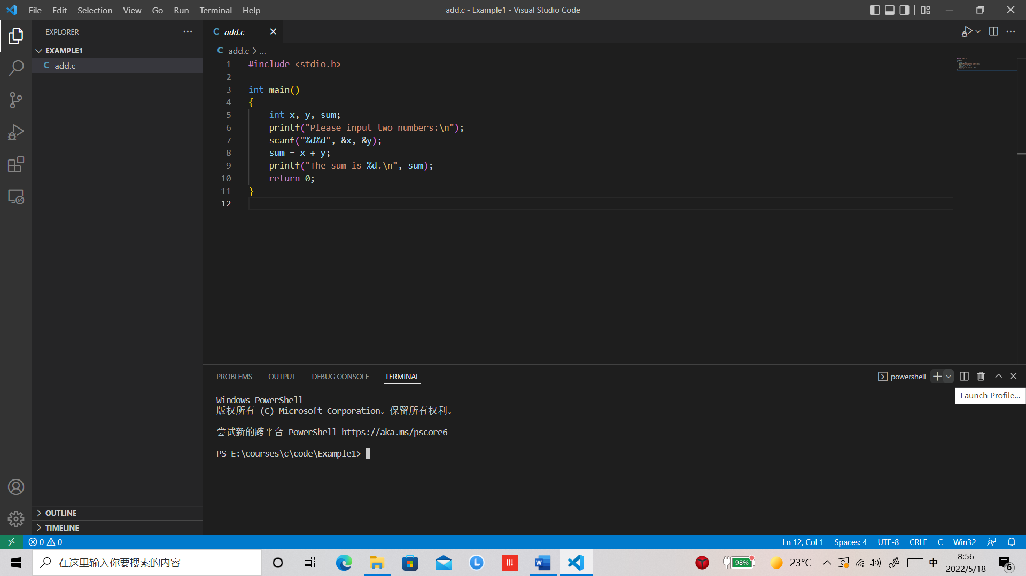

1. 在弹出的下拉菜单中选择“Command Prompt“，如下图所示：

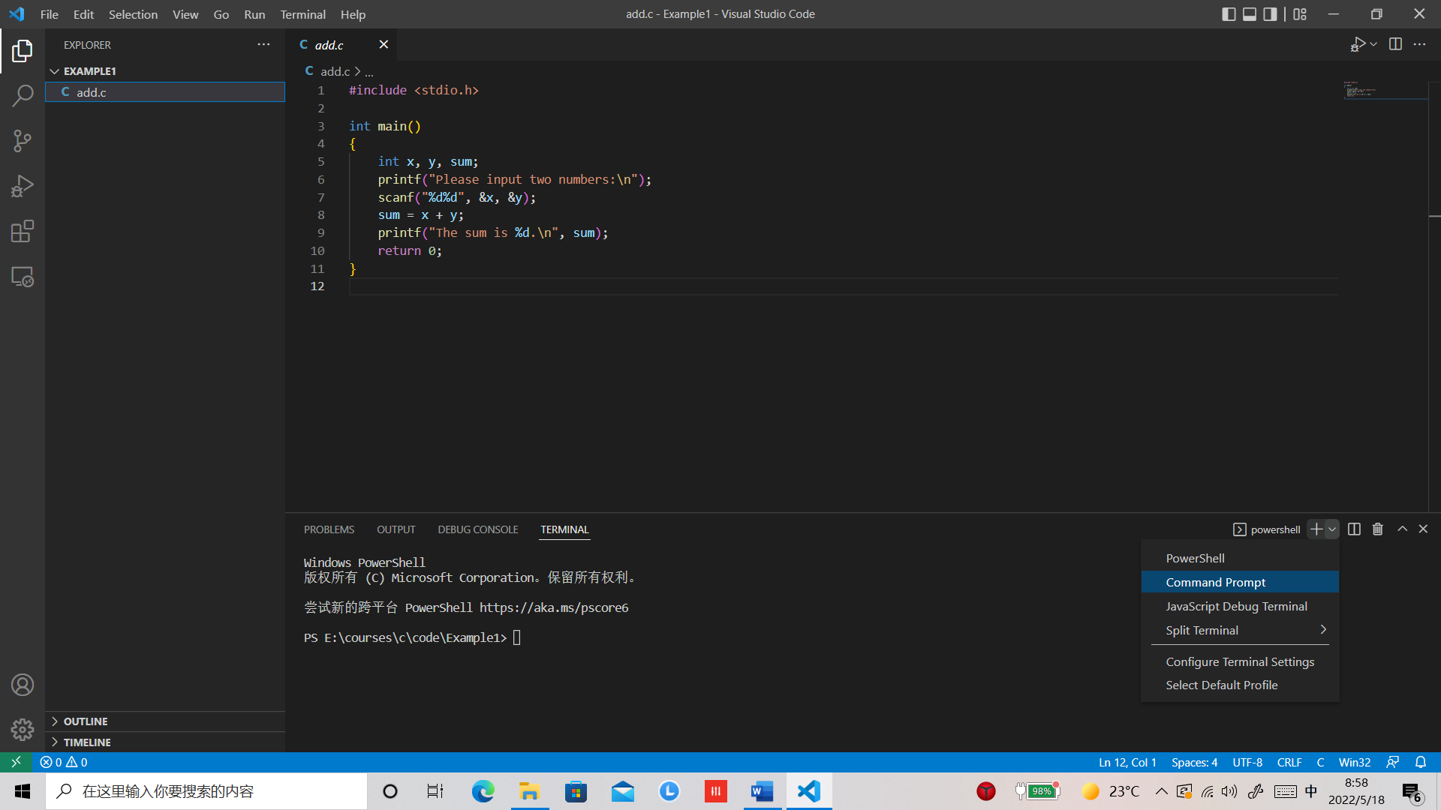

1. 在TERMINAL窗口输入如下命令：

gcc -o add add.c

如下图所示：

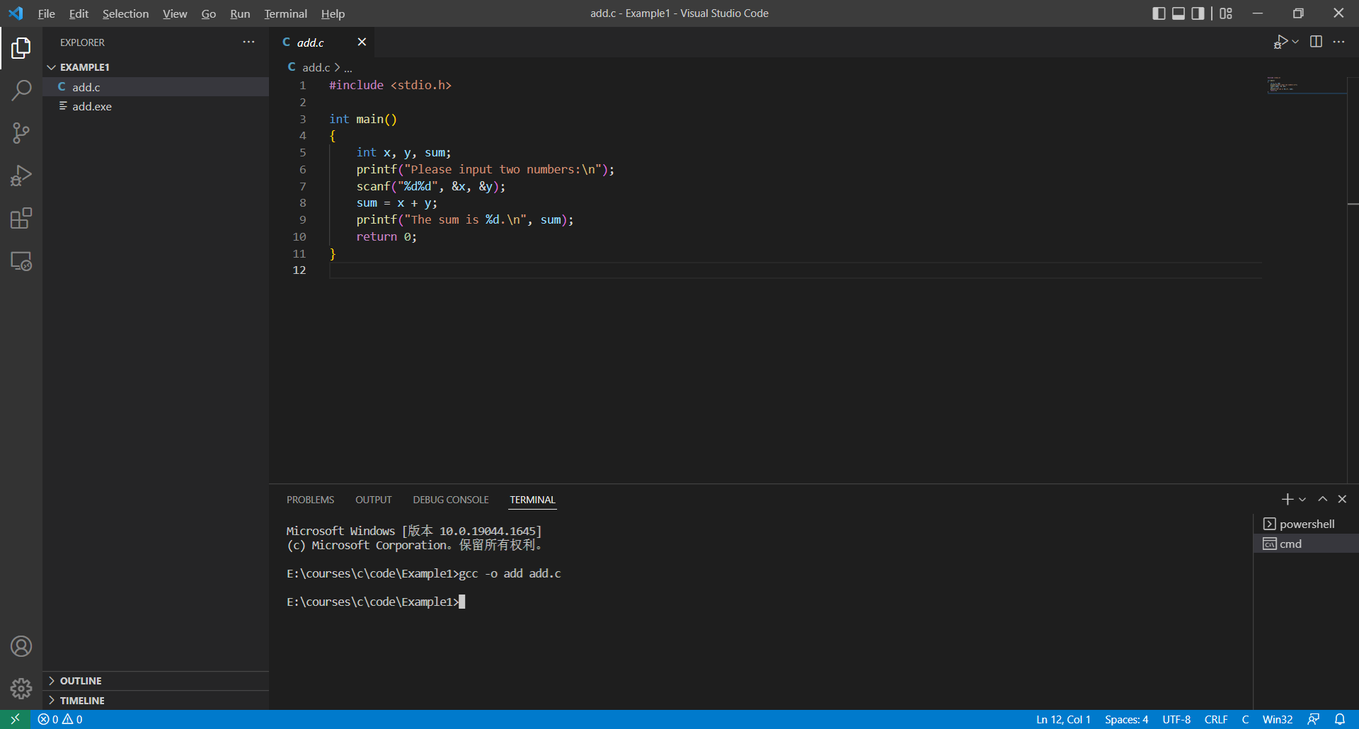

1. 在TERMINAL窗口输入如下命令运行上一步编译生成的add.exe可执行文件，

E:\courses\c\code\Example1>.\add

Please input two numbers:

45 67

The sum is 112.

如下图所示：

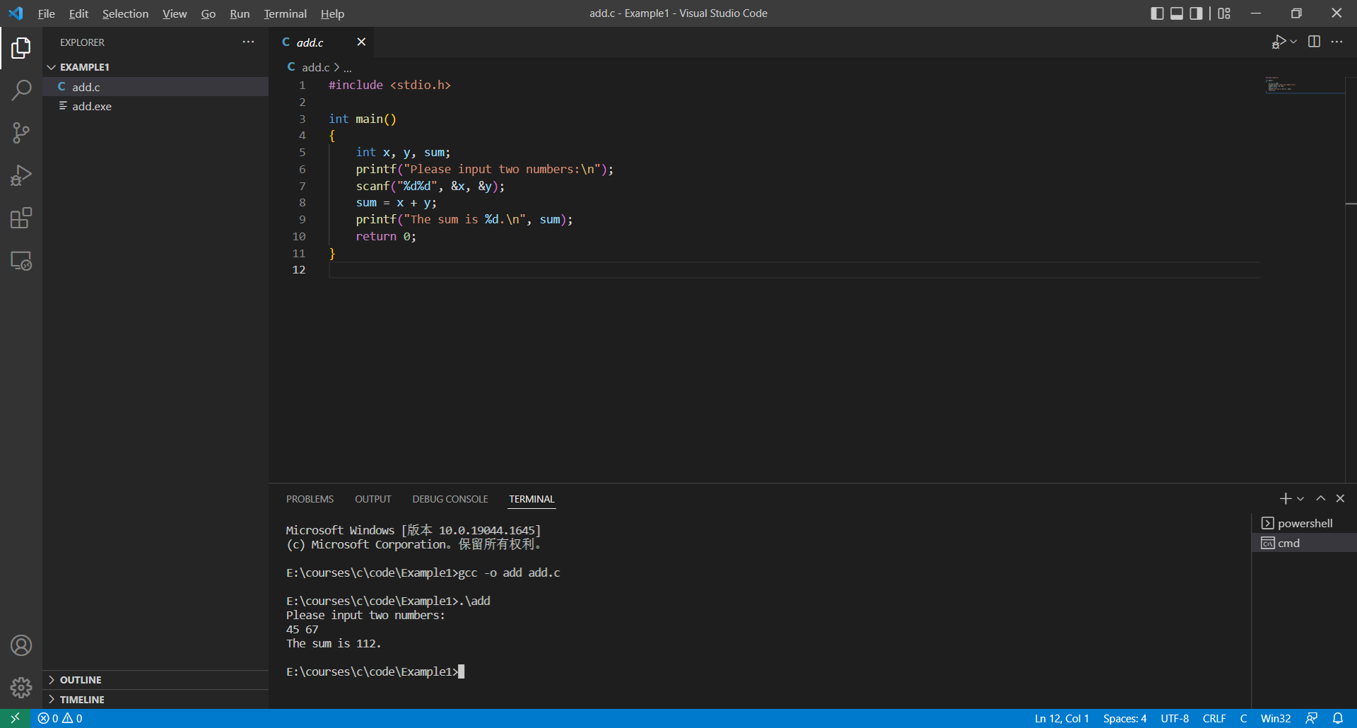

关于如何以可视化的方式在Visual Studio Code中编辑、编译、调试和运行程序，请参考https://code.visualstudio.com/docs/cpp/config-mingw中介绍的步骤。

2. 编写程序，从键盘输入两个单精度浮点数，计算它们的和并在屏幕上输出。

程序运行示例：

Please input two numbers:

123.444444444 123.444444444

The sum is 246.888885.

#include <stdio.h>

int main()

{

    float x, y, sum;

    printf("Please input two numbers:\n");

    scanf("%f%f", &x, &y);

    sum = x + y;

    printf("The sum is %f.\n", sum);

    return 0;

}

3. 编写程序，从键盘输入两个双精度浮点数，计算它们的和并在屏幕上输出。

程序运行示例：

Please input two numbers:

123.444444444 123.444444444

The sum is 246.888889.

#include <stdio.h>

int main()

{

    double x, y, sum;

    printf("Please input two numbers:\n");

    scanf("%lf%lf", &x, &y);

    sum = x + y;

    printf("The sum is %f.\n", sum);

    return 0;

}

4. 编写程序，将从键盘输入的小写字母转换成大写字母并在屏幕上输出。

程序运行示例：

Please input a lowercase character:i

I

#include <stdio.h>

int main()

{

    int c;

    printf("Please input a lowercase character:");

    c = getchar();

    c = 'A' + (c - 'a');

    putchar(c);

    return 0;

}

5. 利用函数递归调用输出一个正整数的二进制表示。

对于任意一个正整数n=bk-1*\*2k-1+bk-2\**2k-2+… + b1\**21+b0\**20，可以递归的定义其二进制表示如下：

当n/2=0时，n的二进制表示n%2(0或1)；

当n/2>0时，n的二进制表示为n/2的二进制表示后接n%2，这里n/2=bk-1*\*2k-2+bk-2\**2k-3+… + b1*20。

程序运行示例：

6

110

#include <stdio.h>

void printd(int x);

int main()

{

    int x;

    scanf("%d", &x);

    printd(x);

    return 0;

}

void printd(int x)

{

    if (x/2)

        printd(x/2);

    putchar(x%2 + '0');

}

以下为调试以上程序的过程：

E:\courses\C\Test>gcc -g -o printd printd.c

这里-g参数表示在编译生成的可执行文件中加入调试信息。

E:\courses\C\Test>gdb printd

GNU gdb (GDB) 8.1

Copyright (C) 2018 Free Software Foundation, Inc.

License GPLv3+: GNU GPL version 3 or later <http://gnu.org/licenses/gpl.html>

This is free software: you are free to change and redistribute it.

There is NO WARRANTY, to the extent permitted by law.  Type "show copying"

and "show warranty" for details.

This GDB was configured as "x86_64-w64-mingw32".

Type "show configuration" for configuration details.

For bug reporting instructions, please see:

<http://www.gnu.org/software/gdb/bugs/>.

Find the GDB manual and other documentation resources online at:

<http://www.gnu.org/software/gdb/documentation/>.

For help, type "help".

Type "apropos word" to search for commands related to "word"...

Reading symbols from printd...done.

(gdb) list

1       #include <stdio.h>

2       void printd(int x);

3       int main()

4       {

5           int x;

6           scanf("%d", &x);

7           printd(x);

8           return 0;

9       }

10

(gdb) list

11      void printd(int x)

12      {

13          if (x/2)

14              printd(x/2);

15          putchar(x%2 + '0');

16      }

(gdb) break main

Breakpoint 1 at 0x40155d: file printd.c, line 6.

(gdb) run

Starting program: E:\courses\C\Test\printd.exe

[New Thread 14504.0x10f8]

[New Thread 14504.0x3aec]

Thread 1 hit Breakpoint 1, main () at printd.c:6

6           scanf("%d", &x);

(gdb) next

6

7           printd(x);

(gdb) print x

$1 = 6

(gdb) x/1wt &x

0x61fe1c:       00000000000000000000000000000110

(gdb) step

printd (x=6) at printd.c:13

13          if (x/2)

(gdb) s

14              printd(x/2);

(gdb) s

printd (x=3) at printd.c:13

13          if (x/2)

(gdb) s

14              printd(x/2);

(gdb) s

printd (x=1) at printd.c:13

13          if (x/2)

(gdb) backtrace

<code>#</code>0  printd (x=1) at printd.c:13

<code>#</code>1  0x00000000004015ae in printd (x=3) at printd.c:14

<code>#</code>2  0x00000000004015ae in printd (x=6) at printd.c:14

<code>#</code>3  0x000000000040157a in main () at printd.c:7

(gdb) s

15          putchar(x%2 + '0');

(gdb) s

116     }

(gdb) s

printd (x=3) at printd.c:15

15          putchar(x%2 + '0');

(gdb) s

116     }

(gdb) s

printd (x=6) at printd.c:15

15          putchar(x%2 + '0');

(gdb) s

016     }

(gdb) s

main () at printd.c:8

8           return 0;

(gdb) s

9       }

(gdb) quit

A debugging session is active.

        Inferior 1 [process 14504] will be killed.

Quit anyway? (y or n) y

E:\courses\C\Test>

我们可以利用x/Nuf expr命令查看地址expr中的内容，其中N为一个数字，表示要查看的单元的个数；u为单元的大小，可以取值为b（字节）,h（两个字节）,w（四个字节）,g（八个字节）；f表示输出的格式，可以取值为x（十六进制），d(带符号十进制)，u(无符号十进制)，o（八进制），t（二进制），a(地址)，c（字符），f（浮点数），s(字符串)。例如，命令x/1wt &x查看从变量x的地址开始的内存单元的内容，查看1个单元，每个单元四个字节，以二进制的格式输出。

6. 以下程序代码从键盘接收一个字符串，先逆序输出该字符串，然后再输出输入的字符串本身。该程序代码对有的输入运行正确，对有的输入运行不正确，请分析代码找出原因，并改正代码。

在笔者的计算机上，第一次运行得到了想要的结果：

输入：

abc

输出：

abccba

第二次运行没有得到想要的结果：

输入：

abcdefghi

输出：

ihgfedcbaabcdefghi_眺

#include <stdio.h>

#include <string.h>

int main()

{

    int i, len;

    char a[21], b[41];

    gets(a);

    len = strlen(a);

    int j = len - 1;

    for (i = 0; i < len; i++)

    {

        b[i] = a[j];

        j--;

    }

    j = 0;

    for (i = len; i < 2 * len; i++)

    {

        b[i] = a[j];

        j++;

    }

    puts(b);

    return 0;

}

在”char a[21], b[41];”后面添加如下输出数组b中元素的代码段：

  for (i = 0; i < 41; i++)

        printf("%d ", b[i]);

printf("\n");

完整代码如下所示：

#include <stdio.h>

#include <string.h>

int main()

{

    int i, len;

    char a[21], b[41];

    for (i = 0; i < 41; i++)

        printf("%d ", b[i]);

    printf("\n");

    gets(a);

    len = strlen(a);

    int j = len - 1;

    for (i = 0; i < len; i++)

    {

        b[i] = a[j];

        j--;

    }

    j = 0;

    for (i = len; i < 2 * len; i++)

    {

        b[i] = a[j];

        j++;

    }

    puts(b);

    return 0;

}

第一次运行过程如下所示：

1 0 0 0 0 0 0 0 0 0 0 0 0 0 0 0 112 22 48 -74 -9 127 0 0 16 0 0 0 0 0 0 0 0 0 0 0 0 0 0 0 0

abc

cbaabc

第二次运行过程如下所示：

1 0 0 0 0 0 0 0 0 0 0 0 0 0 0 0 112 22 48 -74 -9 127 0 0 16 0 0 0 0 0 0 0 0 0 0 0 0 0 0 0 0

abcdefghi

ihgfedcbaabcdefghi0恩

通过分析，我们发现，数组b中元素的值是随机的，b[6]的值恰好为0，b[16]的值为112。对于第一次运行过程，b[6]的值恰好为所得字符串的末尾添加了一个”\0”，所以得到了想要的结果。对于第二次运行过程，就没有那么幸运了。

在”puts(b)”一行的前面添加”b[2*len]=0;”，即可修正代码中的错误，如下所示：

#include <stdio.h>

#include <string.h>

int main()

{

    int i, len;

    char a[21], b[41];

    /* for (i = 0; i < 41; i++)

        printf("%d ", b[i]);

    printf("\n"); */

    gets(a);

    len = strlen(a);

    int j = len - 1;

    for (i = 0; i < len; i++)

    {

        b[i] = a[j];

        j--;

    }

    j = 0;

    for (i = len; i < 2 * len; i++)

    {

        b[i] = a[j];

        j++;

    }

    b[2*len] = 0;

    puts(b);

    return 0;

}

第二章

1.从键盘输入两个整数，输出两者中最大的数。

程序运行示例：

Please input two integers:100 200

The max is 200

#include <stdio.h>

int main()

{

    int x, y;

    int max;

    printf("Please input two integers:");

    scanf("%d%d", &x,&y);

    if (x > y)

        max = x;

    else

        max = y;

    printf("The max is %d\n", max);

    return 0;

}

打印输出ascii码表。

#include <stdio.h>

int main()

{

    for (unsigned char c = 0; c <= 127; c ++)

        printf("%d:%c\n", c, c);

    return 0;

}

1. 由用户输入一个double类型的值，输出它的平方根。

x的平方根采用如下迭代公式进行计算：

$$\left\{\begin{matrix}y_{0}=x \\ y_{n}=\frac{1}{2}(y_{n-1}+\frac{x}{y_{n-1}})\end{matrix}\right.$$

#include <stdio.h>

#define eps 1e-7

int main()

{

    double x;

    printf("Please input a number:");

    scanf("%lf",&x);

    double y = x;

    while (y * y - x >= eps || y * y - x <= -eps) {

        y = 1.0/2.0 * (y + x / y);

    }

    printf("The squre root of %f is %f\n", x, y);

    return 0;

}

第三章

1. 不调用系统库函数，自己编写一个函数计算x的正弦值。

x的正弦值采用如下迭代公式进行计算：

$$\sin\left(x\right)=x-\frac{x^{3}}{3!}+\frac{x^{5}}{5!}-\frac{x^{7}}{7!}+…+{(-1)}^{k-1}\frac{x^{2k-1}}{\left(2k-1\right)!}+{(-1)}^{k}\frac{\sin^{\left(2k+1\right)}(θ)}{\left(2k+1\right)!}x^{2k+1}$$

其中 $θ∈\left(0,x\right)$。

#define eps 1e-9

double Sin(double x){

    double y = 0;

    double delta = x;

    int n = 1;

    while (delta >= eps || delta <= -eps ){

        y += delta;

        delta *= -x/ (n + 1) * x /( n + 2);

        n += 2;

    };

    return y;

}

int main()

{

    double x;

    for (x = 0.0; x <= 6.28; x += 0.01){

        printf("Sin(%4.2f)=%9.6f\t", x, Sin(x));

        printf("%9.6f\n", sin(x));

    }

    return 0;

}

3. 编写程序，输入一个整数并输出，输出时要求从右边起每三个数位加一个","。

   程序运行示例：

   12345

   12,345

4. 编写程序，从用户输入的带路径和扩展名的文件名中提取文件名（去掉路径前缀和扩展名）

    程序运行示例：

    abc/def/file.txt

    file

5. 程序改错。以下程序判定一个字符串是否是另一个字符串的逆序，如果是，返回值为1，如果不是，返回值为0。该程序中存在两处错误，请改正。

#include <stdio.h>

#include <string.h>

int is_reverse(char *word1, char *word2) {

    int i = 0;

    int j = strlen(word2);

    while (j > 0) {

        if (word1[i] != word2[j])

            return 0;

        i++;

        j--;

    }

    if (word1[i] != '\0')

        return 0;

    else

        return 1;

}

int main(int argc, char const *argv[])

{

    printf("%d\n", is_reverse("stop", "pots"));

    printf("%d\n", is_reverse("stop", "pot"));

    return 0;

}

6. 检索一个单词表中所有的回文。单词表存放在文件word.txt中，每行存放一个单词。

7. 完成以下的divmod函数，计算整数a除以b所得到的商和余数。

#include <stdio.h>

struct pair {

    int quotient;

    int remainder;

};

struct pair divmod(int a, int b)

{

}

int main()

{

    int a = 8, b = 3;

    struct pair result = divmod(a, b);

    printf("The quotient is %d, and the remainder is %d", result.quotient, result.remainder);

    return 0;

}

9.编写程序生成svg文件，画出如下图形：

由用户输入一个整数n，1 $≤n≤9，$

当n=2时，

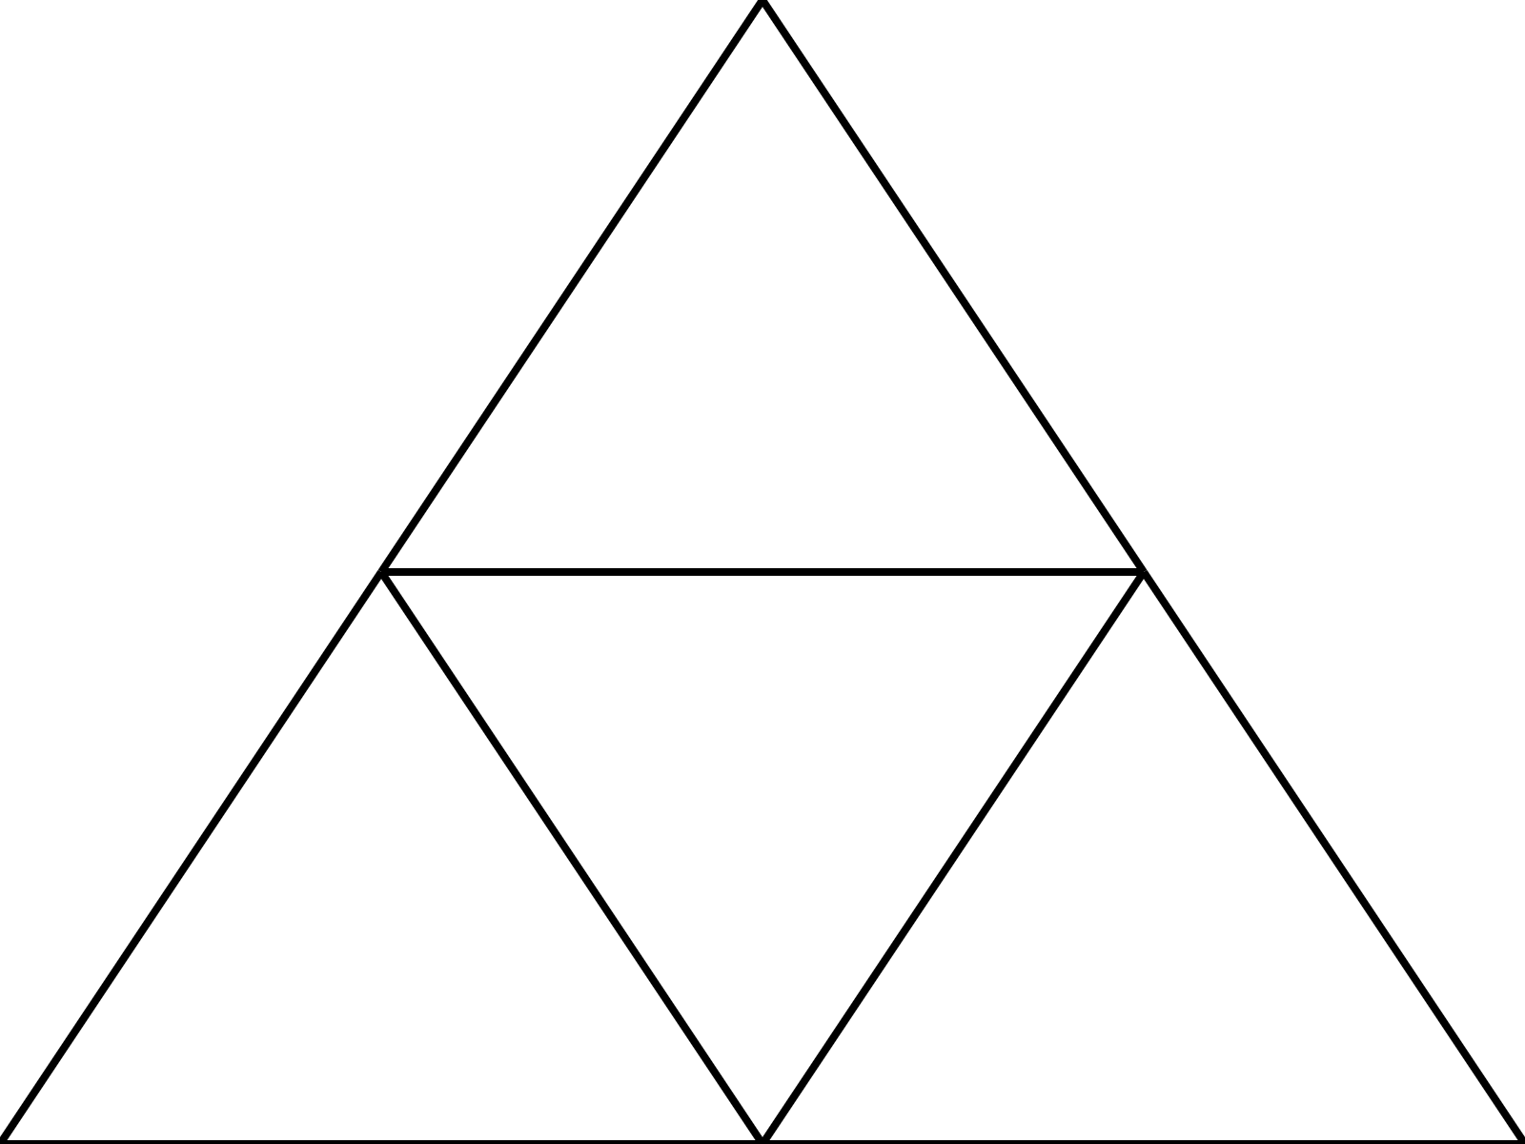

当n=3时，

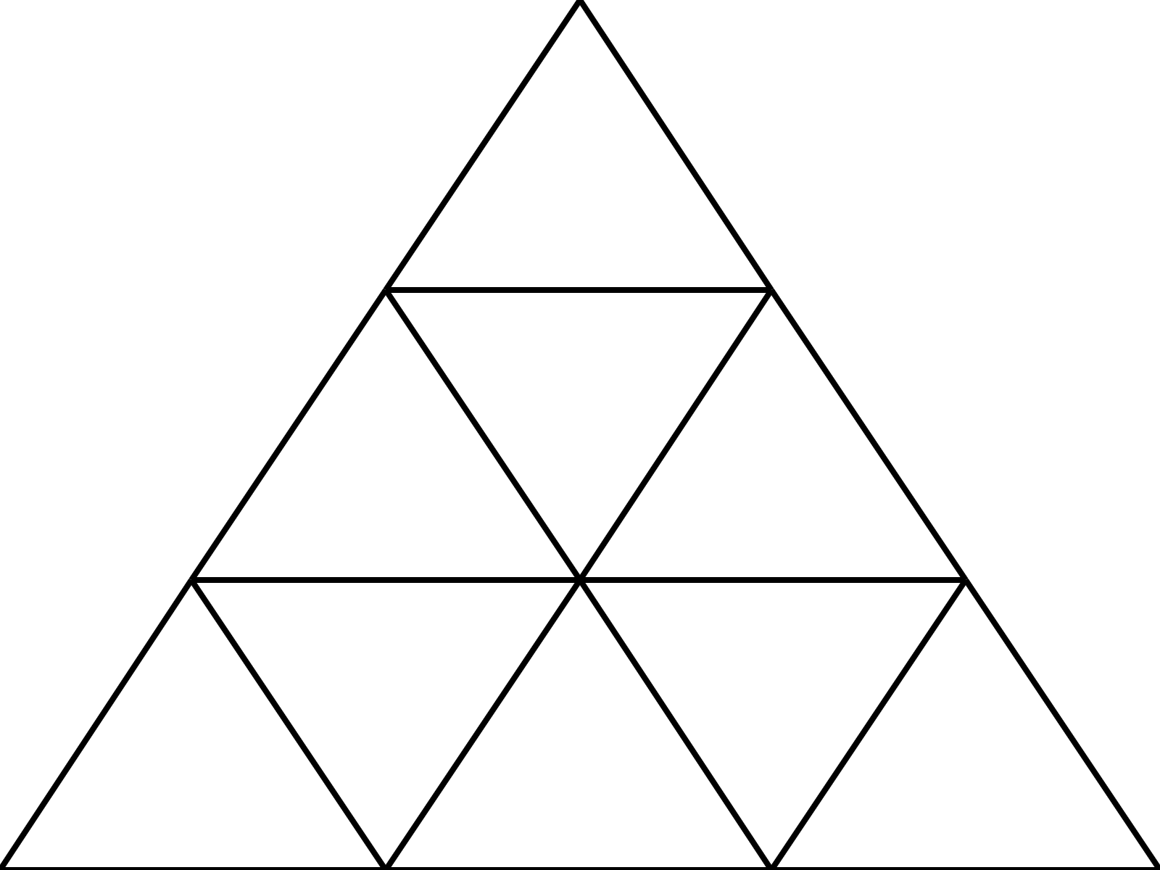

当n=9时

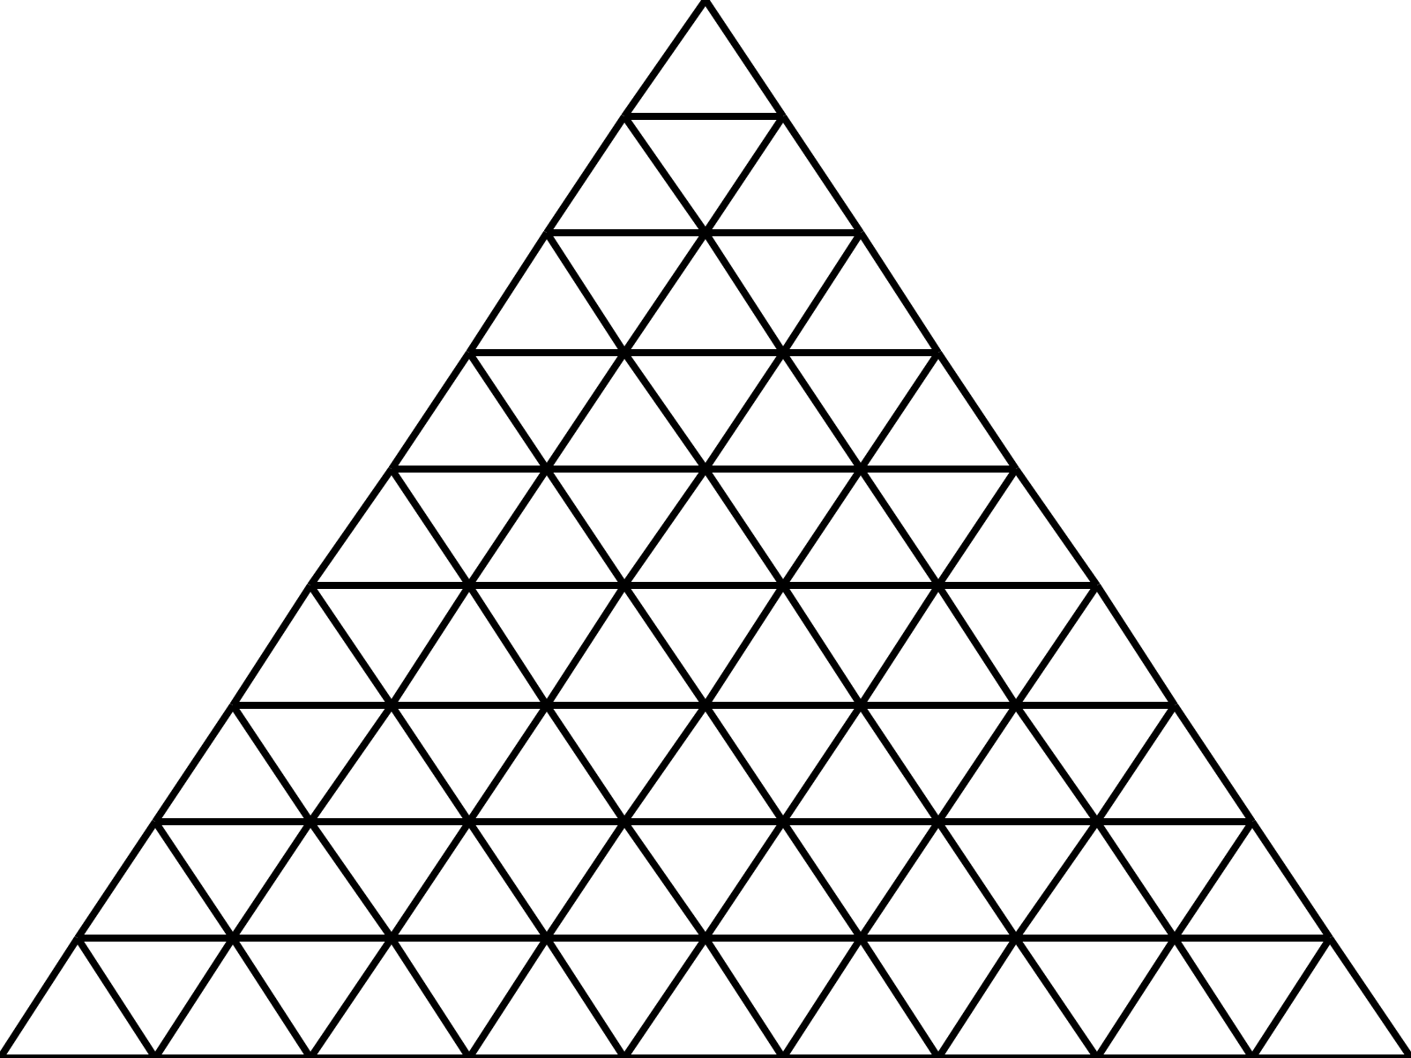

#include <stdio.h>

#include <string.h>

#include <stdlib.h>

#include <math.h>

#define PI 3.141592653589793

#define WIDTH 400

#define HEIGHT 300

int n;

FILE *fp;

struct point {

    int x;

    int y;

};

struct point pixel(double dx, double dy)

{

    double xscale = (double)WIDTH / n;

    double yscale = (double)HEIGHT / (n * sin(PI/3));

    struct point p;

    p.x = dx * xscale;

    p.y = HEIGHT - dy * yscale;

    return p;

}

void draw_triangle(double dx, double dy)

{

    struct point p1 = pixel(dx, dy);

    struct point p2 = pixel(dx + 1, dy);

    struct point p3 = pixel(dx + cos(PI/3), dy + sin(PI/3));

    fprintf(fp, "<line x1='%d' y1='%d' x2='%d' y2='%d' stroke='black' stroke-width='2'/>\n", p1.x, p1.y, p2.x, p2.y);

    fprintf(fp, "<line x1='%d' y1='%d' x2='%d' y2='%d' stroke='black' stroke-width='2'/>\n", p2.x, p2.y, p3.x, p3.y);

    fprintf(fp, "<line x1='%d' y1='%d' x2='%d' y2='%d' stroke='black' stroke-width='2'/>\n", p3.x, p3.y, p1.x, p1.y);

}

int main()

{

    printf("Please input n:");

    scanf("%d", &n);

    char *name = (char *)malloc(strlen("triangles")+ 6);

    strcpy(name, "triangles");

    *(name + strlen("triangles")) = '0'+n;

    strcpy(name+strlen("triangles") + 1, ".svg");

    fp = fopen(name,"w");

    fprintf(fp, "<svg xmlns='http://www.w3.org/2000/svg' width='%d' height='%d'>", WIDTH, HEIGHT);

    double px = 0;

    double py = 0;

    int m = n;

    for (int i = 0; i < n; i++)

    {

        for (int j = 0; j < m; j++) {

            draw_triangle(px + j, py);

        }

        m--;

        px += cos(PI/3);

        py += sin(PI/3);

    }

    fprintf(fp, "</svg>");

    fclose(fp);

    return 0;

}

**Description**

It’s a series problem. Supposing a number is given, try to approach to it by the sum of 1/n. That is, given an X, you should compute the maximum of n in the following inequality:

1/2+1/3+...+1/(n+1) ≤X

For example, when the input X is 1.00, it acts as follows:

1/2+1/3+1/4+1/5>1.00

1/2+1/3+1/4≤1.00

So you should output n=3.

An exception is that if X is less than 0.5, 1 should be output.

**Input**

The program should be run all the time until you give it a significant sign to stop. Each line shows a positive floating-point number X whose value is at least 0.01 and at most 10.25.

When X=0.00, the program would be exited.

**Output**

Print the maximum of n in one line.

**Sample Input**

1.00

3.71

0.04

5.19

0.00

**Sample Output**

3

61

1

273

#include <stdio.h>

int main()

{

    double f;

    while (scanf("%lf", &f) == 1 && f != 0.00)

    {

        int count = 0;

        double fsum = 0.0;

        while (fsum < f && ++count)

            fsum += (double) (1.0 / (count + 1));

        printf("%d\n", count);

    }

    return 0;

}

**Description**

An easy problem, output the sum area of the triangles.

**Input**

The program should be run all the time until you give it a significant sign to stop.

First input the number of triangles, N (0<=N<=100).

Then, give out coordinates of 3 points of a triangle, formatted by(x, y) in each line.

When N =0, the program would be exited.

**Output**

For each test case, output the total area, and the number should be rounded to 9 places after the decimal point.

**Sample Input**

2

1.0 2.0 3.0 4.0 5.0 6.0

1.0 2.0 3.0 4.0 5.0 7.0

2

1.0 2.0 3.0 4.0 5.0 6.0

2.0 3.0 4.0 5.0 6.0 7.0

3

1.0 2.0 2.0 3.0 3.0 4.0

2.0 3.0 3.0 4.0 4.0 5.0

3.0 4.0 4.0 5.0 5.0 6.0

2

1.2 2.3 3.4 4.5 5.6 6.7

5.6 6.7 7.8 8.9 9.0 1.2

0

**Sample Output**

The Total Area is 1.000000000.

No Area.

No Area.

The Total Area is 9.790000000.

#include<stdlib.h>

#include<stdio.h>

//#include<iostream>

//#include<iomanip>

#include<math.h>

//using namespace std;

double Area(double x0,double y0,double x1,double y1,double x2,double y2)

{

    return fabs((x1-x0)*(y2-y0)-(x2-x0)*(y1-y0));

}

int main()

{

    double x0,y0,x1,y1,x2,y2,area;

    int t;

    while(scanf("%d",&t)==1&&t!=0)

    {

        area=0;

        for(int i=0;i<t;i++)

        {

            scanf("%lf%lf%lf%lf%lf%lf",&x0,&y0,&x1,&y1,&x2,&y2);

            area+=Area(x0,y0,x1,y1,x2,y2);

        }

        if(fabs(area)<5e-10)

            printf("No Area.");

        else

            printf("The Total Area is %.9lf.\n",0.5*area);

            //cout<<"The Total Area is "<<fixed<<setprecision(9)<<0.5*area<<"."<<endl;

    }

    return 0;

}

**Description**

There is a set called S, which is defined as follows:

(1) 1 is in S;

(2) If x is in S, then 2x + 1 and 3x + 1 are also in S;

(3) No other element belongs to S.

The element of the S is sorted in increasing order. Please find the Nth element.

**Input**

The program should be run all the time until you give it a significant sign to stop.

Each line has one positive integer N (1 <= N <= 1000000).

**Output**

For each test case, output the corresponding element in S.

**Sample Input**

5

13

100

254

**Sample Output**

9

28

418

1461

#include<stdio.h>

#include<stdlib.h>

unsigned int a[1000000];

int n;

void Init()

{

    int i, j, k, t1, t2;

    a[j = i = 0] = 1;

    for (k = 1; k < 1000000; k++) {

        t1 = 2 * a[i] + 1;

        t2 = 3 * a[j] + 1;

        if (t1 == t2) {

            a[k] = t1;

            i++;

            j++;

            continue;

        }

        a[k] = min(t1, t2);

        if (a[k] == t1)

            i++;

        else

            j++;

    }

}

int main()

{

    Init();

    while (scanf("%d",&n)==1)

        printf("%d\n",a[n-1]);

        //cout << a[n - 1] << endl;

    return 0;

}

**Description**

Assuming a positive integer series like this: A1，A2，A3，A4，A5，A6，A7. Every time you can only pick out one element, which is to be used to calculate a value, from the head or the bottom of the series.

For example:

1st, A1 is chosen, the left series is A2，A3，A4，A5，A6，A7;

2nd, A7 is chosen, the left series is A2，A3，A4，A5，A6;

3rd, A6 is chosen, the left series is A2，A3，A4，A5;

4th, A2 is chosen, the left series is A3，A4，A5;

5th, A5 is chosen, the left series is A3，A4;

6th, A3 is chosen, the left series is A4;

7th, A4 is chosen, the left series is empty.

Value=A1*1+A7*2+A6*3+A2*4+A5*5+A3*6+A4*7. You have many ways to choose. Please find a maximum of the Value.

**Input**

The program should be run all the time until you give it a significant sign to stop. First input the number N (0<=N<=1000) of the elements in the series. Then the following N lines give out the element positive integer, in the range [1, 1000].

When the N=0, the program would be exited.

**Output**

Print the max Value for a single line.

**Sample Input**

11

5 3 6 10 6 7 5 10 2 9 2

10

9 1 1 1 1 1 8 8 8 8

0

**Sample Output**

The Max Value Is 446.

The Max Value Is 301.

#include<stdio.h>

using namespace std;

int a[1001];

int dp[1001][1001];

int n;

inline int max(int a,int b)

{

    if(a>b)

        return a;

    return b;

}

int main()

{

    int i,j,k;

    while(scanf("%d",&n)==1&&n!=0)

    {

        for(i=1;i<=n;i++)

        {

         scanf("%d",&j);

            //cin>>j;

            a[i]=a[i-1]+(dp[i][i]=j);

        }

        for(k=1;k<=n-1;k++)

        for(i=1;i+k<=n;i++)

        {

            j=i+k;

            dp[i][j]=max(dp[i+1][j],dp[i][j-1])+a[j]-a[i-1];

        }

        printf("The Max Value Is %d.\n",dp[1][n]);

        //cout<<"The Max Value Is "<<dp[1][n]<<"."<<endl;

    }

    return 0;

}

**Description**

Bob doesn't have a high intelligence quotient, so he often has difficulties in math. This time he has a hard problem, please help him.

The task is to calculate the factorial of the non-negative integer.

**Input**

The program should be run all the time until you give it a significant sign to stop.

Input the integer N in the range [0, 10000].

When N=-1, the program would be exited.

**Output**

Print the factorial of the integer in a single line.

**Sample Input**

2

5

4

0

-1

**Sample Output**

2

120

24

1

#include<stdio.h>

#include<memory.h>

int main()

{

    int Data[40000];

    int digit;

    int i,j,r,k;

    int N;

    while(scanf("%d",&N)==1&&N!=-1)

    {

        memset(Data,0,sizeof(Data));

        digit=Data[0]=Data[1]=1;

        for(i=1;i<N+1;i++)

        {

            for(j=1;j<digit+1;j++)

                Data[j]*=i;

            for(j=1;j<digit+1;j++)

            {

                if(Data[j]>10)

                {

                    for(r=1;r<digit+1;r++)

                    {

                        if(Data[digit]>9)

                            digit++;

                        Data[r+1]+=Data[r]/10;

                        Data[r]=Data[r]%10;

                    }

                }

            }

        }

        for(k=digit;k>0;k--)

           printf("%d",Data[k]);

       printf("\n");

    }

       return 0;

}

**Description**

One day, Mingming was taken to a restaurant. The waiter took her M pears and N plates. She was ordered to put the pears into plates. Plates could be empty after the task is done. Please help her.

For examples:

[1], 3 pears in 2 plates, you can do it in 2 ways: (0; 3) or (1; 2).

[2], 3 pears in 4 plates, you can do it in 3 ways (0,0,0,3) (0,0,1,2) (0,1,1,1), where,(0,1,1,1) and (1,1,1,0) are the same case.

**Input**

The program should be run all the time until you give it a significant sign to stop. First input the integer M in the range [1, 99]. Then input the integer N in the range [1, 99].

When M=N=0, the program would be exited.

**Output**

Print the number of the ways in a single line.

**Sample Input**

3 9

6 7

2 8

6 4

0 0

**Sample Output**

3

11

2

9

#include<stdio.h>

//using namespace std;

int Fun(int M,int N)

{

    if(M==0||N==1)

        return 1;

    if(M<0)

        return 0;

    return Fun(M-N,N)+Fun(M,N-1);

}

int main()

{

    int M,N;

    while(scanf("%d%d",&M,&N)==2&&M!=0&&N!=0)

        printf("%d\n",Fun(M,N));

        //cout<<Fun(M,N)<<endl;

    return 0;

}

**Description**

Mother McQueen has built a network for school. There are N buildings in the campus. She needs to put a high speed connection to ensure that she could net with any building. In decreasing the cost, it is unnecessary to connect every two buildings; in addition, you should keep the buildings connectable with each other.

For example:

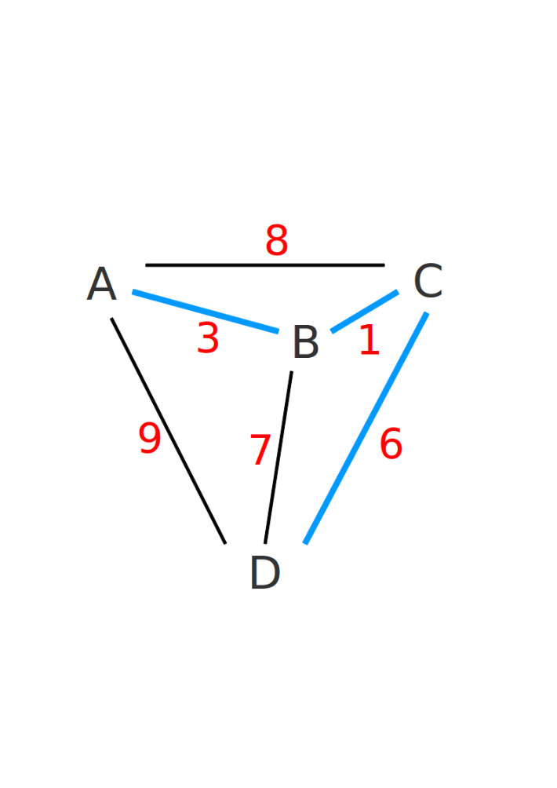There are four buildings in the campus: A、B、C、D

The distance between A and B is 3.

The distance between A and C is 8.

The distance between A and D is 9.

The distance between B and C is 1.

The distance between B and D is 7.

The distance between C and D is 6.

And A->B, B->C, and C->D are the answers.

The distance is 3+1+6=10.

Input

The program should be run all the time until you give it a significant sign to stop.

First input the integer N in the range [1,1111]. Then a matrix of N*N will be input as the distance between each two buildings. The element in the matrix is a integer in the range [1,111111].

If N=0, the program would be exited.

**Output**

Print the minimum of total distance in a single line.

**Sample Input**

4

0 3 8 9

3 0 1 7

8 1 0 6

9 7 6 0

0

**Sample Output**

10

#include<stdio.h>

//using namespace std;

const int MAX=1115;

const int INF=0xfffffff;

int Map[MAX][MAX],Dis[MAX];//Dis[i]表示顶点i与生成树之间的最短距离。

int min(int a,int b)

{

    return a<b?a:b;

}

int Prim(int N)

{

    int i,j,now,min_edge,min_node,Ans=0;

    for(i=1;i<=N;i++)

        Dis[i]=INF;

    for(now=i=1;i<N;i++)

    {

        Dis[now]=-1;

        min_edge=INF;

        for(j=1;j<=N;j++)

        {

            if(now!=j&&Dis[j]>=0)

            {

                Dis[j]=min(Dis[j],Map[now][j]);

                if(Dis[j]<min_edge)

                {

                    min_edge=Dis[j];

                    min_node=j;

                }

            }

        }

        now=min_node;

        Ans+=min_edge;

    }

    return Ans;

}

int main()

{

    int i,j,N;

    while(scanf("%d",&N)==1&&N!=0)

    {

        for(i=1;i<=N;i++)

        for(j=1;j<=N;j++)

            scanf("%d",Map[i][j]);

            //cin>>Map[i][j];

        printf("%d\n",Prim(N));

        //cout<<Prim(N)<<endl;

    }

    return 0;

}

**Description**

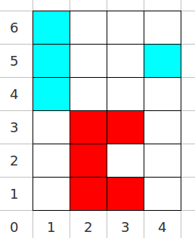Little Wu has built a farm for his son. The size of the farm is N*M. On the farm, there are wet areas and dry areas. Trees can be planted on wet areas. The task is to find the biggest number of the wet areas, which is called a part. A part could be counted by connecting squares that must link each other in up, bottom, left, or right directions.

For example:

The farm is listed as follows and its size is 4*6.

The coordinates of wet areas have been colored. They are:

(3,3) (3,1) (1,6) (1,4) (4,5) (2,1) (1,5) (2,2) (2,3)

The others are dry areas who are not colored.

And the biggest wet part is the dark, see the right figure.

**Input**

The program should be run all the time until you give it a significant sign to stop.

First input the integer N and M in the range [1,128]. Then input T (1<=T<=N*M) as the number of wet areas. The following T lines give out the coordinates of wet areas formatted (X, Y), where, 1<=X<=N, 1<=Y<=M.

When N=M=T=0, the program would be exited.

**Output**

Print the number of the max wet areas.

**Sample Input**

4 6 9

3 3

3 1

1 6

1 4

4 5

2 1

1 5

2 2

2 3

0 0 0

**Sample Output**

5

#include<stdio.h>

#include<string.h>

//using namespace std;

const int MAX=130;

int Flag[MAX][MAX];

int Num;

void DFS(int i,int j)

{

    if(Flag[i][j])

    {

        Num++;

        Flag[i][j]=0;

        DFS(i-1,j);

        DFS(i+1,j);

        DFS(i,j-1);

        DFS(i,j+1);

    }

}

int main()

{

    int i,j,m,n,t,x,y,temp;

    while(scanf("%d%d%d",&n,&m,&t)==3&&n!=0&&m!=0)

    {

        memset(Flag,0,sizeof(Flag));

        for(i=0;i<t;i++)

        {

            scanf("%d%d",&x,&y);

            //cin>>x>>y;

            Flag[x][y]=1;

        }

        temp=0;

        for(i=1;i<=n;i++)

        for(j=1;j<=m;j++)

            if(Flag[i][j])

            {

                Num=0;

                DFS(i,j);

                if(Num>temp)

                    temp=Num;

            }

        printf("%d\n",temp);

        //cout<<temp<<endl;

    }

    return 0;

}

**Description**

Mrs. Fax has stolen some electric cables. For strange reason, she must cut the cables into the same length and they should be as long as possible. If she can't do that, the God will punish her. Please save her. Note, the cable can not be jointed by each other.

For example:

There are 4 cables. The length of them is as follows:

4.22

7.14

3.28

6.22

And if she is needed to cut them into 9 pieces with the same length, the result is 2.07. Specifically, she cut them one by one as follows:

4.22 into 2 piece 2.07 2.07

7.14 into 3 piece 2.07 2.07 2.07

3.28 into 1 piece 2.07

6.22 into 3 piece 2.07 2.07 2.07

**Input**

The program should be run all the time until you give it a significant sign to stop.

First input the integer N in the range [1, 1000] as the number of the cables. Then input M in the range [1, 50000] as the number of the pieces to be cut. After that, the following N lines give out the length with 2 decimal by float in the range [1, 10000] of every cable.

When N=M=0, the program would be exited.

**Output**

Print the max length in a single line.

**Sample Input**

4 9

4.22

7.14

3.28

6.22

**Sample Output**

2.07

#include<stdio.h>

#include<string.h>

//using namespace std;

int a[1000];

int N,M;

int check(int value)

{

    int cnt=0,i;

    for(i=0;i<N;i++)

        cnt+=a[i]/value;

    if(cnt>=M)

        return 1;

    return 0;

}

int main()

{

    int i,left,right,mid;

    double value;

    while(scanf("%f%f",&N,&M)==2&&N!=0&&M!=0)

    {

        left=1;right=0;

        for(i=0;i<N;i++)

        {

            scanf("%f",&value);

            //cin>>value;

            a[i]=(int)(100*value);

            if(a[i]>right)

                right=a[i];

        }

        while(left<=right)

        {

            mid=(left+right)/2;

            if(check(mid))

                left=mid+1;

            else right=mid-1;

        }

        printf("%.2f\n",right*0.01);

    }

    return 0;

}

计算两个矩阵的成绩。矩阵A存放在文件A.dat中，矩阵B存在文件B.dat中，矩阵A与矩阵B的乘积输出文件C.dat中。各文件中第一行的两个数字为矩阵的行数和列数。

A.dat示例：

2 3

1.0 2.0 3.0

4.0 5.0 6.0

B.dat 示例：

3 4

1.0 2.0 3.0 4.0

5.0 6.0 7.0 8.0

9.0 10.0 11.0 12.0

程序输出的C.dat 示例：

2 4

38.000000 44.000000 50.000000 56.000000

83.000000 98.000000 113.000000 128.000000

#include <stdio.h>

#include <stdlib.h>

struct Matrix {

    double *d;

    int r;

    int c;

};

typedef struct Matrix Matrix;

void init_matrix(Matrix *M, char *file_name);

Matrix multiply(Matrix A, Matrix B);

void output(Matrix M, char *file_name);

void clear_matrix(Matrix *M);

int main()

{

    Matrix A;

    init_matrix(&A, "A.dat");

    Matrix B;

    init_matrix(&B, "B.dat");

    Matrix C = multiply(A, B);

    char *file_name = "C.dat";

    output(C, file_name);

    printf("output written to %s.", file_name);

    clear_matrix(&A);

    clear_matrix(&B);

    clear_matrix(&C);

    return 0;

}

void init_matrix(Matrix *M, char *file_name)

{

    FILE *fp = fopen(file_name, "r");

    fscanf(fp, "%d%d", &M->r, &M->c);

    M->d = (double *)malloc(M->r * M->c * sizeof(double));

    for (int i = 0; i < M->r; i ++)

        for (int j = 0; j < M->c; j ++)

            fscanf(fp, "%lf", &M->d[i * M->c + j]);

    fclose(fp);

}

Matrix multiply(Matrix A, Matrix B)

{

    Matrix C;

    C.r = A.r;

    C.c = B.c;

    C.d = (double *)malloc(A.r * B.c * sizeof(double));

    for (int i = 0; i < C.r; i ++)

        for (int j = 0; j < C.c; j ++) {

            C.d[i * C.c + j] = 0.0;

            for (int k = 0; k < A.c; k ++)

                C.d[i * C.c + j] += A.d[i * A.c + k] * B.d[k * B.c + j];

        }

    return C;

}

void output(Matrix M, char *file_name)

{

    FILE *fp = fopen(file_name, "w");

    fprintf(fp, "%d ", M.r);

    fprintf(fp, "%d \n", M.c);

    for (int i = 0; i < M.r; i ++) {

        for (int j = 0; j < M.c; j ++)

            fprintf(fp, "%f ", M.d[i * M.c + j]);

        fprintf(fp, "\n");

    }

    fclose(fp);

}

void clear_matrix(Matrix *M)

{

    free(M->d);

}

从键盘输入两个向量，计算它们的和。向量的维数任意，用顺序存储结构实现。

程序运行示例：

输入：

1 2 3 4

5 6 7 8

输出：

6.000000 8.000000 10.000000 12.000000

list.h:

#ifndef List_H

#define List_H

typedef double ElemType;

struct List {

    ElemType *elem;

    int size; // number of elements;

    int capacity; //size of allocated storage capacity

    int i;

};

typedef struct List List;

void init_list(struct List *p);

void push_back(struct List *p, ElemType val);

void input_list(struct List *p);

void output_list(struct List *p);

void clear_list(struct List *p);

ElemType at(struct List *p, int i);

void init_iterator(struct List *p);

int has_next(struct List *p);

ElemType next(struct List *p);

#endif

list.c

#include <stdio.h>

#include <stdlib.h>

#include "list.h"

void init_list(List *p)

{

    p->elem = NULL;

    p->size = 0;

    p->capacity = 0;

}

void push_back(List *p, ElemType val)

{

    if (p->size == p->capacity)

    {

        int newalloc = (p->capacity + 1) * 2;

        ElemType *q = (ElemType *)malloc(newalloc * sizeof(ElemType));

        p->capacity = newalloc;

        for (int i = 0; i < p->size; i++)

            q[i] = p->elem[i];

        free(p->elem);

        p->elem = q;

    }

    p->elem[p->size++] = val;

}

void input_list(List *p)

{

    ElemType x;

    while (1) {

        int c;

        while((c = getchar()) == ' ');

        if (c == '\n')

            break;

        else

            ungetc(c, stdin);

        if (scanf("%lf", &x) != 1) break;

        push_back(p, x);

    }

}

void output_list(List *p)

{

    for (int i = 0; i < p->size; i ++)

        printf("%f ", p->elem[i]);

}

ElemType at(List *p, int i)

{

    return p->elem[i];

}

void clear_list(List *p)

{

    free(p->elem);

}

void init_iterator(List *p)

{

    p->i = 0;

}

int has_next(List *p)

{

    return p->i < p->size;

}

ElemType next(List *p)

{

    p->i ++;

    return p->elem[p->i - 1];

}

list_test.c:

#include "list.h"

int main()

{

    List v1;

    init_list(&v1);

    input_list(&v1);

    List v2;

    init_list(&v2);

    input_list(&v2);

    List v3;

    init_list(&v3);

    init_iterator(&v1);

    init_iterator(&v2);

    while(has_next(&v1)) {

        push_back(&v3, next(&v1) + next(&v2));

    }

    output_list(&v3);

    clear_list(&v1);

    clear_list(&v2);

    clear_list(&v3);

    return 0;

}

从键盘输入两个向量，计算它们的和。向量的维数任意，用链式存储结构实现。

程序运行示例：

输入：

1 2 3 4

5 6 7 8

输出：

6.000000 8.000000 10.000000 12.000000

list.h:

#ifndef List_H

#define List_H

typedef double ElemType;

struct Node {

    ElemType item;

    struct Node *next;

};

struct List {

    struct Node *first;

    struct Node *last;

    struct Node *i;

};

typedef struct List List;

void init_list(struct List *p);

void push_back(struct List *p, ElemType val);

void input_list(struct List *p);

void output_list(struct List *p);

void clear_list(struct List *p);

ElemType at(struct List *p, int i);

void init_iterator(struct List *p);

int has_next(struct List *p);

ElemType next(struct List *p);

#endif

list.c:

#include <stdio.h>

#include <stdlib.h>

#include "list.h"

void init_list(List *p)

{

    p->first = NULL;

    p->last = NULL;

}

void push_back(List *p, ElemType val)

{

    struct Node *r = (struct Node *)malloc(sizeof(struct Node));

    r->item = val;

    r->next = NULL;

    if (p->last == NULL) {

        p->first = r;

    } else {

        p->last->next = r;

    }

    p->last = r;

}

void input_list(List *p)

{

    ElemType x;

    while (1) {

        int c;

        while((c = getchar()) == ' ');

        if (c == '\n')

            break;

        else

            ungetc(c, stdin);

        if (scanf("%lf", &x) != 1) break;

        push_back(p, x);

    }

}

void output_list(List *p)

{

    for (struct Node *q = p->first; q != NULL; q = q->next)

        printf("%f ", q->item);

}

ElemType at(struct List *p, int i)

{

    struct Node *r = p->first;

    for (int j = 0; j < i; i ++) {

        if (r == NULL) exit(1);

        r = r->next;

    }

    if (r == NULL) exit(1);

    return r->item;

}

void clear_list(List *p)

{

    struct Node *t;

    for (struct Node *q = p->first; q != NULL; q = t) {

        t = q->next;

        free(q);

    }

}

void init_iterator(List *p)

{

    p->i = p->first;

}

int has_next(List *p)

{

    return p->i != NULL;

}

ElemType next(List *p)

{

    ElemType x  = p->i->item;

    p->i = p->i->next;

    return x;

}

list_test.c:

#include "list.h"

int main()

{

    List v1;

    init_list(&v1);

    input_list(&v1);

    List v2;

    init_list(&v2);

    input_list(&v2);

    List v3;

    init_list(&v3);

    init_iterator(&v1);

    init_iterator(&v2);

    while(has_next(&v1)) {

        push_back(&v3, next(&v1) + next(&v2));

    }

    output_list(&v3);

    clear_list(&v1);

    clear_list(&v2);

    clear_list(&v3);

    return 0;

}

输入一个十进制数，输出其二进制表示。用栈实现。

程序运行示例：

输入：

100

输出：

1100100

stack.h:

#ifndef STACK_H

#define STACK_H

typedef int ElemType;

struct Node {

    ElemType item;

    struct Node *next;

};

struct Stack {

    struct Node *first;

    struct Node *last;

};

typedef struct Stack Stack;

void init_stack(Stack *p);//construct stack

int empty(Stack *p);//test whether the stack is empty, return value 1 for empty, 0 for non-empty

void push(Stack *p, ElemType val);//insert element

void pop(Stack *p);//remove the top element

ElemType top(Stack *p);//return the top element, the top element is not removed

void clear_stack(Stack *p);//destroy stack

#endif

stack.c:

#include <stdio.h>

#include <stdlib.h>

#include "Stack.h"

void init_stack(Stack *p)

{

    p->first = NULL;

    p->last = NULL;

}

int empty(Stack *p)

{

    return p->first == NULL;

}

void push(Stack *p, ElemType val)

{

    struct Node *r = (struct Node *)malloc(sizeof(struct Node));

    r->item = val;

    r->next = p->first;

    p->first = r;

    if (p->last == NULL) {

        p->last = r;

    }

}

void pop(Stack *p)

{

    if (p->first == NULL) {

        printf("error:stack empty!\n");

        exit(1);

    }

    if (p->last == p->first) {

        p->last = NULL;

    }

    struct Node *t = p->first;

    p->first = p->first->next;

    free(t);

}

ElemType top(Stack *p)

{

    return p->first->item;

}

void clear_stack(Stack *p)

{

    while(!empty(p))

        pop(p);

}

stack_test.c:

#include <stdio.h>

#include "stack.h"

int main()

{

    int x;

    scanf("%d", &x);

    Stack s;

    init_stack(&s);

    do

    {

        push(&s, x%2);

        x /= 2;

    } while (x != 0);

    while (!empty(&s)) {

        putchar(top(&s) + '0');

        pop(&s);

    }

    return 0;

}

实现队列的链式存储结构。从键盘依次输入任意多个整数入队列，以“#”结束，然后依次出队列输出各个整数。

程序运行示例：

输入：

1 2 3 4 5 6 #

输出：

1 2 3 4 5 6

queue.h:

#ifndef QUEUE_H

#define QUEUE_H

typedef int ElemType;

struct Node {

    ElemType item;

    struct Node *next;

};

typedef struct Node Node;

struct Queue {

    struct Node *first;

    struct Node *last;

};

typedef struct Queue Queue;

void init_queue(Queue *p);//construct queue

int empty(Queue *p);//test whether the queue is empty, return value 1 for empty, 0 for non-empty

void push(Queue *p, ElemType val);//insert element at the end of the queue

void pop(Queue *p);//remove the front element

ElemType front(Queue *p);//return the front element, the front element is not removed

void clear_queue(Queue *p);

#endif

queue.c:

#include <stdio.h>

#include <stdlib.h>

#include "queue.h"

void init_queue(Queue *p)

{

    p->first = NULL;

    p->last = NULL;

}

int empty(Queue *p)

{

    return p->first == NULL;

}

void push(Queue *p, ElemType val)

{

    struct Node *r = (Node *)malloc(sizeof(struct Node));

    r->item = val;

    r->next = NULL;

    if (p->last == NULL) {

        p->first = r;

        p->last = r;

    } else {

        p->last->next = r;

        p->last= r;

    }

}

void pop(Queue *p)

{

    if (p->first == NULL) {

        printf("error:Queue empty!\n");

        exit(1);

    }

    if (p->last == p->first) {

        p->last = NULL;

    }

    struct Node *t = p->first;

    p->first = p->first->next;

    free(t);

}

ElemType front(Queue *p)

{

    return p->first->item;

}

void clear_queue(Queue *p)

{

    while(!empty(p))

        pop(p);

}

queue_test.c:

#include <stdio.h>

#include "queue.h"

int main()

{

    Queue q;

    init_queue(&q);

    int key;

    while(scanf("%d", &key) == 1) {

        push(&q, key);

    }

    while (!empty(&q)){

        printf("%d ", front(&q));

        pop(&q);

    }

    clear_queue(&q);

    return 0;

}

程序运行示例：

输入：

whatever is worth doing is worth doing well

^Z

输出：

doing:2

is:2

well:1

whatever:1

worth:2

#include <stdio.h>

#include <stdlib.h>

#include <string.h>

struct Node {

    char *item;

    int count;

    struct Node *left;

    struct Node *right;

};

void insert(struct Node **pr, char *s);

//struct Node *insert(struct Node *p, char *w);

void output_tree(struct Node *root);

void clear_tree(struct Node *root);

int main()

{

    struct Node *root = NULL;

    char word[100];

    while(scanf("%s", word) == 1)

        insert(&root, word);

//        root = insert(root, word);

    output_tree(root);

    clear_tree(root);

    return 0;

}

void insert(struct Node **pr, char *s)

{

    struct Node *prev = NULL;

    struct Node *p = *pr;

    int result;

    while(p != NULL) {

        prev = p;

        result = strcmp(s, p->item);

        if (result == 0) {

            p->count ++;

            return;

        } else if (result < 0) {

            p = p->left;

        } else if (result > 0) {

            p = p->right;

        }

    }

    struct Node *q = (struct Node *)malloc(sizeof(struct Node));

    q->item = (char *)malloc(strlen(s) + 1);

    strcpy(q->item, s);

    q->count = 1;

    q->left = NULL;

    q->right = NULL;

    if (prev == NULL) {

        *pr = q;

    } else if (result < 0) {

        prev->left = q;

    } else if(result > 0) {

        prev->right = q;

    }

}

void output_tree(struct Node *root)

{

    if (root != NULL) {

        output_tree(root->left);

        printf("%s:%d\n", root->item, root->count);

        output_tree(root->right);

    }

}

void clear_tree(struct Node *root)

{

    if (root != NULL) {

        clear_tree(root->left);

        clear_tree(root->right);

        free(root->item);

        free(root);

    }

}

从键盘接收图的邻接矩阵，输出图的顶点集合和边的集合。

程序运行示例：

输入：

7

0 1 0 0 0 0 1

0 0 1 0 0 0 0

0 0 0 1 0 1 0

0 0 0 0 1 0 0

0 0 0 0 0 0 0

0 0 0 0 1 0 0

0 0 1 0 0 0 0

输出：

G=(V,E)

V={0,1,2,3,4,5,6}

E={(0,1),(0,6),(1,2),(2,3),(2,5),(3,4),(5,4),(6,2)}

adjacency_matrix.h:

#ifndef ADJACENCY_MATRIX_H

#define ADJACENCY_MATRIX_H

#include <stdio.h>

#include <stdlib.h>

struct graph {

    int* edge;

    int nv; //number of vertices

};

typedef struct graph graph;

void init_graph(graph *G, int nv);//初始化图G

void set_edge(graph *G, int v1, int v2);//建立v1和v2之间的一条边，顶点集不变

int is_edge(graph *G, int v1, int v2);//判断从v1到v2是否有边

void input_graph(graph *G);//读取图

void output_graph(graph *G);//输出图G

void clear_graph(graph *G);//释放图G的存储空间

#endif // ADJACENCY_MATRIX_H

adjacency_matrix.c:

#include "adjacency_matrix.h"

#include "string.h"

void init_graph(graph *G, int nv)

{

    G->nv = nv;

    G->edge = (int*) malloc (G->nv * G->nv * sizeof(int));

    /*

    for (int i = 0; i < nv; i ++)

        for (int j = 0; j < nv; j ++)

            G->edge[i * nv + j] = 0;

            */

    memset(G->edge, 0, G->nv * G->nv * sizeof(int));

}

void set_edge(graph *G, int v1, int v2)

{

    G->edge[v1 * G->nv + v2] = 1;

}

int is_edge(graph *G, int v1, int v2)

{

    return G->edge[v1 * G->nv + v2];

}

void input_graph(graph *G)

{

    int n;

    scanf("%d", &n);

    init_graph(G, n);

    int e;

    for (int i = 0; i < n; i ++)

        for (int j = 0; j < n; j ++){

            scanf("%d", &e);

            if (e == 1) set_edge(G, i, j);

        }

}

void output_graph(graph *G)

{

    printf("G=(V,E)\n");

    printf("V={");

    for (int i = 0; i < G->nv - 1; i ++)

        printf("%d,", i);

    printf("%d", G->nv - 1);

    printf("}\n");

    printf("E={");

    int number = 0;

    for (int i = 0; i < G->nv; i ++) {

        for (int j = 0; j < G->nv; j ++) {

                if (is_edge(G, i, j)) {

                    if (number > 0) printf(",");

                    printf("(%d,%d)", i, j);

                    number++;

                }

        }

    }

    printf("}\n");

}

void clear_graph(graph *G)

{

    free(G->edge);

}

adjacency_matrix_test.c:

#include <stdio.h>

#include <stdlib.h>

#include "adjacency_matrix.h"

int main()

{

    graph* G = (graph*)malloc(sizeof(graph));

    printf("Please input the graph:\n");

    input_graph(G);

    output_graph(G);

    clear_graph(G);

    return 0;

}

从键盘接收图的邻接表，输出图的顶点集合和边的集合。

程序运行示例：

输入：

7

0: 1 6

1: 2

2: 3 5

3: 4

4:

5: 4

6: 2

^Z

输出：

G=(V,E)

V={0,1,2,3,4,5,6}

E={(0,6),(0,1),(1,2),(2,5),(2,3),(3,4),(5,4),(6,2)}

Adjacency_list.h:

#ifndef ADJACENCY_LIST_H

#define ADJACENCY_LIST_H

struct node {

    int v;

    struct node *next;

};

typedef struct node node;

struct graph {

    int nv;      //number of vertices

    node **adj;

};

typedef struct graph graph;

void init_graph(graph *G, int nv);//初始化图G

void set_edge(graph *G, int v1, int v2);//建立v1和v2之间的一条边，顶点集不变

int is_edge(graph *G, int v1, int v2);//判断从v1到v2是否有边

void input_graph(graph *G);//读取图

void output_graph(graph *G);//输出图G

void clear_graph(graph *G);//释放图G的存储空间

#endif // ADJACENCY_LIST_H

adjacency_list.c:

#include <stdio.h>

#include <stdlib.h>

#include "adjacency_list.h"

void skip_blank(void)

{

    int c;

    while((c = getchar()) == ' ');

    ungetc(c, stdin);

}

void init_graph(graph *G, int nv)

{

    G->nv = nv;

    G->adj = (node **)malloc(G->nv * sizeof(node *));

    for (int i = 0; i < G->nv; i ++)

        G->adj[i] = NULL;

}

void set_edge(graph *G, int v1, int v2)

{

    node *q = (node *) malloc(sizeof(node));

    q->v = v2;

    q->next = G->adj[v1];

    G->adj[v1] = q;

}

int is_edge(graph *G, int v1, int v2)

{

    for (node *p = G->adj[v1]; p != NULL; p = p->next) {

        if (p->v == v2)

            return 1;

    }

    return 0;

}

void input_graph(graph *G)

{

    int nv;

    scanf("%d", &nv);

    init_graph(G, nv);

    while(1) {

        int u;

        if (scanf("%d:", &u) != 1) break;

        skip_blank();

        int c;

        while((c = getchar()) != '\n') {

            ungetc(c, stdin);

            int v;

            scanf("%d", &v);

            set_edge(G, u, v);

            skip_blank();

        }

    }

}

void output_graph(graph *G)

{

    printf("G=(V,E)\n");

    printf("V={");

    for (int i = 0; i < G->nv - 1; i ++)

        printf("%d,", i);

    printf("%d", G->nv - 1);

    printf("}\n");

    printf("E={");

    int number = 0;

    for (int i = 0; i < G->nv; i ++)

    {

        for (node *p = G->adj[i]; p != NULL; p = p->next) {

            if (number >=1) printf(",");

            printf("(%d,%d)", i, p->v);

            number ++;

        }

    }

    printf("}\n");

}

void clear_graph(graph *G)

{

    for (int i = 0; i < G->nv; i ++) {

        node * q;

        for (node *p = G->adj[i]; p != NULL; p = q) {

            q = p->next;

            free(p);

        }

    }

    free(G->adj);

}

adjacency_list_test.c:

#include <stdio.h>

#include <stdlib.h>

#include "adjacency_list.h"

int main()

{

    graph* G = (graph*)malloc(sizeof(struct graph));

    printf("Please input the graph:\n");

    input_graph(G);

    output_graph(G);

    clear_graph(G);

    return 0;

}

实现图的广度优先搜索算法。

程序运行示例：

Please input the graph:

7

0: 1  6

1: 2

2: 3  5

3: 4

4:

5: 4

6: 2

^Z

Please input the source:0

0 discovered with distance 0

6 discovered with distance 1

1 discovered with distance 1

2 discovered with distance 2

5 discovered with distance 3

3 discovered with distance 3

4 discovered with distance 4

Please input the destination:4

The shortest path is:0 6 2 5 4

Adjacency_list.h:

#ifndef ADJACENCY_LIST_H

#define ADJACENCY_LIST_H

struct node {

    int v;

    struct node *next;

};

typedef struct node node;

struct vertex {

    int discovered;

    int distance;

    int predecessor;

};

typedef struct vertex vertex;

struct graph {

    int nv;      //number of vertices

    node **adj;

    vertex *vertices;

};

typedef struct graph graph;

void init_graph(graph *G, int number_of_vertices);//初始化图G

void set_arc(graph *G, int v1, int v2);//建立v1和v2之间的一条边，顶点集不变

int is_arc(graph *G, int v1, int v2);//判断从v1到v2是否有边

void input_graph(graph *G);//读取图

void output_graph(graph *G);//输出图G

void clear_graph(graph *G);//释放图G的存储空间

#endif // ADJACENCY_LIST_H

adjacency_list.c:

#include <stdio.h>

#include <stdlib.h>

#include "adjacency_list.h"

void init_graph(graph *G, int nv)

{

    G->nv = nv;

    G->vertices = (vertex *)malloc(G->nv * sizeof(vertex));

    G->adj = (node **)malloc(G->nv * sizeof(node *));

    for (int i = 0; i < G->nv; i ++)

        G->adj[i] = NULL;

}

void set_edge(graph *G, int v1, int v2)

{

    node* q = (node *) malloc(sizeof(node));

    q->v = v2;

    q->next = G->adj[v1];

    G->adj[v1] = q;

}

void input_graph(graph *G)

{

    int nv;

    scanf("%d", &nv);

    init_graph(G, nv);

    while(1) {

        int u;

        if (scanf("%d:", &u) != 1) break;

        int c;

        while((c = getchar()) == ' ' || c == '\t');

        ungetc(c, stdin);

        while((c = getchar()) != '\n') {

            ungetc(c, stdin);

            int v;

            scanf("%d", &v);

            set_edge(G, u, v);

            while((c = getchar()) == ' ' || c == '\t');

            ungetc(c, stdin);

        }

    }

}

void output_graph(graph *G)

{

    printf("G=(V,E)\n");

    printf("V={");

    for (int i = 0; i < G->nv - 1; i ++)

        printf("%d,", i);

    printf("%d", G->nv - 1);

    printf("}\n");

    printf("E={");

    int number = 0;

    for (int i = 0; i < G->nv; i ++)

    {

        node *p = G->adj[i];

        while(p != NULL)

        {

            if (number >=1) printf(",");

            printf("(%d,%d)", i, p->v);

            number ++;

            p = p->next;

        }

    }

    printf("}\n");

}

void clear_graph(graph *G)

{

    for (int i = 0; i < G->nv; i ++) {

        node * q;

        for (node *p = G->adj[i]; p != NULL; p = q) {

            q = p->next;

            free(p);

        }

    }

    free(G->adj);

}

queue.h:

#ifndef QUEUE_H

#define QUEUE_H

typedef int ElemType;

struct Node {

    ElemType item;

    struct Node *next;

};

typedef struct Node Node;

struct Queue {

    struct Node *first;

    struct Node *last;

};

typedef struct Queue Queue;

void init_queue(Queue *p);

int empty(Queue *p);

void push(Queue *p, ElemType val);

void pop(Queue *p);

ElemType front(Queue *p);

void clear_queue(Queue *p);

#endif

queue.c:

#include <stdio.h>

#include <stdlib.h>

#include "queue.h"

void init_queue(Queue *p)

{

    p->first = NULL;

    p->last = NULL;

}

int empty(Queue *p)

{

    return p->first == NULL;

}

void push(Queue *p, ElemType val)

{

    struct Node *r = (Node *)malloc(sizeof(struct Node));

    r->item = val;

    r->next = NULL;

    if (p->last == NULL) {

        p->first = r;

        p->last = r;

    } else {

        p->last->next = r;

        p->last= r;

    }

}

void pop(Queue *p)

{

    if (p->first == NULL) {

        printf("error:Queue empty!\n");

        exit(1);

    }

    if (p->last == p->first) {

        p->last = NULL;

    }

    struct Node *t = p->first;

    p->first = p->first->next;

    free(t);

}

ElemType front(Queue *p)

{

    return p->first->item;

}

void clear_queue(Queue *p)

{

    while(!empty(p))

        pop(p);

}

bfs.h:

#if !defined(BFS_H)

#define BFS_H

#include "adjacency_list.h"

void bfs(graph* G, int s);

void print_path(graph* G, int s, int v);

#endif // BFS_H

bfs.c:

#include <stdio.h>

#include <stdlib.h>

#include "bfs.h"

#include "Queue.h"

void bfs(graph* G, int s)

{

    for(int i = 0; i < G->nv; i ++) {

            G->vertices[i].discovered = 0;

            G->vertices[i].distance = -1; // -1 for infinity

            G->vertices[i].predecessor = -1; // -1 for no predecessor

    }

    G->vertices[s].distance = 0;

    printf("%d discovered with distance %d\n", s, G->vertices[s].distance);

    G->vertices[s].discovered = 1;

    Queue *q = (Queue *)malloc(sizeof(Queue));

    init_queue(q);

    push(q,s);

    while (!empty(q)) {

        int u = front(q);

        pop(q);

        for (node *p = G->adj[u]; p != NULL; p = p->next) {

            if (!(G->vertices[p->v].discovered)) {

                G->vertices[p->v].discovered = 1;

                G->vertices[p->v].distance = G->vertices[u].distance + 1;

                G->vertices[p->v].predecessor = u;

                printf("%d discovered with distance %d\n", p->v, G->vertices[p->v].distance);

                push(q,p->v);

            }

        }

    }

}

void print_path(graph* G, int s, int v)

{

    if (v == s)

        printf("%d ", s);

    else if (G->vertices[v].predecessor == -1)

        printf("No path from vertex %d to vertex %d exists.", s, v);

    else {

        print_path(G, s, G->vertices[v].predecessor);

        printf("%d ", v);

    }

}

bfs_test.c:

#include <stdio.h>

#include <stdlib.h>

#include "bfs.h"

int main()

{

    graph* G = (graph*)malloc(sizeof(graph));

    printf("Please input the graph:\n");

    input_graph(G);

    printf("Please input the source:");

    int s;

    scanf("%d", &s);

    bfs(G, s);

    printf("Please input the destination:");

    int t;

    scanf("%d", &t);

    printf("The shortest path is:");

    print_path(G, s, t);

    return 0;

}

实现图的深度优先搜索算法。

程序运行示例：

Please input the graph:

10

0:1

1:6

2:3 1

3:4

4:

5:6 0

6:7

7:8

8:9 2

9:

^Z

0 discovered.

1 discovered.

6 discovered.

7 discovered.

8 discovered.

2 discovered.

3 discovered.

4 discovered.

9 discovered.

5 discovered.

adjacency_list.h:

#ifndef ADJACENCY_LIST_H

#define ADJACENCY_LIST_H

struct node {

    int v;

    struct node *next;

};

typedef struct node node;

struct vertex {

    int discovered;

};

typedef struct vertex vertex;

struct graph {

    int nv;      //number of vertices

    node **adj;

    vertex *vertices;

};

typedef struct graph graph;

void init_graph(graph *G, int number_of_vertices);//初始化图G

void set_arc(graph *G, int v1, int v2);//建立v1和v2之间的一条边，顶点集不变

int is_arc(graph *G, int v1, int v2);//判断从v1到v2是否有边

void input_graph(graph *G);//读取图

void output_graph(graph *G);//输出图G

void clear_graph(graph *G);//释放图G的存储空间

#endif // ADJACENCY_LIST_H

adjacency_list.c:

#include <stdio.h>

#include <stdlib.h>

#include "adjacency_list.h"

void init_graph(graph *G, int nv)

{

    G->nv = nv;

    G->vertices = (vertex *)malloc(G->nv * sizeof(vertex));

    G->adj = (node **)malloc(G->nv * sizeof(node *));

    for (int i = 0; i < G->nv; i ++)

        G->adj[i] = NULL;

}

void set_edge(graph *G, int v1, int v2)

{

    node* q = (node *) malloc(sizeof(node));

    q->v = v2;

    q->next = G->adj[v1];

    G->adj[v1] = q;

}

void input_graph(graph *G)

{

    int nv;

    scanf("%d", &nv);

    init_graph(G, nv);

    while(1) {

        int u;

        if (scanf("%d:", &u) != 1) break;

        int c;

        while((c = getchar()) == ' ' || c == '\t');

        ungetc(c, stdin);

        while((c = getchar()) != '\n') {

            ungetc(c, stdin);

            int v;

            scanf("%d", &v);

            set_edge(G, u, v);

            while((c = getchar()) == ' ' || c == '\t');

            ungetc(c, stdin);

        }

    }

}

void output_graph(graph *G)

{

    printf("G=(V,E)\n");

    printf("V={");

    for (int i = 0; i < G->nv - 1; i ++)

        printf("%d,", i);

    printf("%d", G->nv - 1);

    printf("}\n");

    printf("E={");

    int number = 0;

    for (int i = 0; i < G->nv; i ++)

    {

        node *p = G->adj[i];

        while(p != NULL)

        {

            if (number >=1) printf(",");

            printf("(%d,%d)", i, p->v);

            number ++;

            p = p->next;

        }

    }

    printf("}\n");

}

void clear_graph(graph *G)

{

    for (int i = 0; i < G->nv; i ++) {

        node * q;

        for (node *p = G->adj[i]; p != NULL; p = q) {

            q = p->next;

            free(p);

        }

    }

    free(G->adj);

}

stack.h:

#ifndef STACK_H

#define STACK_H

typedef int ElemType;

struct Node {

    ElemType item;

    struct Node *next;

};

struct Stack {

    struct Node *first;

    struct Node *last;

};

typedef struct Stack Stack;

void init_stack(Stack *p);//construct stack

int empty(Stack *p);//test whether the stack is empty, return value 1 for empty, 0 for non-empty

void push(Stack *p, ElemType val);//insert element

void pop(Stack *p);//remove the top element

ElemType top(Stack *p);//return the top element, the top element is not removed

void clear_stack(Stack *p);//destroy stack

#endif

stack.c:

#include <stdio.h>

#include <stdlib.h>

#include "Stack.h"

void init_stack(Stack *p)

{

    p->first = NULL;

    p->last = NULL;

}

int empty(Stack *p)

{

    return p->first == NULL;

}

void push(Stack *p, ElemType val)

{

    struct Node *r = (struct Node *)malloc(sizeof(struct Node));

    r->item = val;

    r->next = p->first;

    p->first = r;

    if (p->last == NULL) {

        p->last = r;

    }

}

void pop(Stack *p)

{

    if (p->first == NULL) {

        printf("error:stack empty!\n");

        exit(1);

    }

    if (p->last == p->first) {

        p->last = NULL;

    }

    struct Node *t = p->first;

    p->first = p->first->next;

    free(t);

}

ElemType top(Stack *p)

{

    return p->first->item;

}

void clear_stack(Stack *p)

{

    while(!empty(p))

        pop(p);

}

dfs.h:

#ifndef DFS_H

#define DFS_H

#include "adjacency_list.h"

void dfs(graph *G);

#endif // DFS_H

dfs.c:

#include <stdio.h>

#include <stdlib.h>

#include "adjacency_list.h"

#include "dfs.h"

#include "stack.h"

void dfs(graph *G)

{

    for(int i = 0; i < G->nv; i ++) {

            G->vertices[i].discovered = 0;

    }

    for (int i = 0; i < G->nv; i ++)

        if (G->vertices[i].discovered == 0) {

            G->vertices[i].discovered = 1;

            printf("%d discovered.\n", i);

            Stack *s = (Stack *)malloc(sizeof(Stack));

            init_stack(s);

            push(s, i);

            while(!empty(s)){

                int x = top(s);

                int finished = 1;

                for (node *p = G->adj[x]; p != NULL; p = p->next)

                    if (G->vertices[p->v].discovered == 0) {

                        G->vertices[p->v].discovered = 1;

                        printf("%d discovered.\n", p->v);

                        push(s, p->v);

                        finished = 0;

                        break;

                    }

                if (finished)

                    pop(s);

            }

        }

}

dfs_test.c:

#include <stdio.h>

#include <stdlib.h>

#include "adjacency_list.h"

#include "dfs.h"

int main()

{

    graph* G = (graph*)malloc(sizeof(graph));

    printf("Please input the graph:\n");

    input_graph(G);

    dfs(G);

    return 0;

}

实现dijkstra算法。

程序运行示例：

Please input the graph:

7

0: 1 1 6 4

1: 2 7

2: 3 4 5 2

3: 4 5

4:

5: 4 8

6: 2 1

^Z

Please input the source:0

Please input the destination:4

The shortest path is:

0 6 2 3 4

The distance is 14.

Adjacency_list.h:

#ifndef ADJACENCY_LIST_H

#define ADJACENCY_LIST_H

#define INF 0X7FFFFFFF

struct node {

    int v;

    int weight;

    struct node *next;

};

typedef struct node node;

struct vertex {

    int distance;

    int predecessor;

};

typedef struct vertex vertex;

struct graph {

    int nv;      //number of vertices

    node **adj;

    vertex *vertices;

};

typedef struct graph graph;

void init_graph(graph *G, int nv);//初始化图G

void set_edge(graph *G, int v1, int v2, int weight);//建立v1和v2之间的一条边，顶点集不变

int get_edge_weight(graph *G, int v1, int v2);//判断从v1到v2是否有边

void input_graph(graph *G);//读取图

void output_graph(graph *G);//输出图G

void clear_graph(graph *G);//释放图G的存储空间

#endif // ADJACENCY_LIST_H

Adjacency_list.c:

#include <stdio.h>

#include <stdlib.h>

#include "adjacency_list.h"

void skip_blank(void)

{

    int c;

    while((c = getchar()) == ' ');

    ungetc(c, stdin);

}

void init_graph(graph *G, int nv)

{

    G->nv = nv;

    G->vertices = (vertex *)malloc(G->nv * sizeof(vertex));

    G->adj = (node **)malloc(G->nv * sizeof(node *));

    for (int i = 0; i < G->nv; i ++)

        G->adj[i] = NULL;

}

void set_edge(graph *G, int v1, int v2, int weight)

{

    node *q = (node *) malloc(sizeof(node));

    q->v = v2;

    q->weight = weight;

    q->next = G->adj[v1];

    G->adj[v1] = q;

}

int get_edge_weight(graph *G, int v1, int v2)

{

    for (node *p = G->adj[v1]; p != NULL; p = p->next) {

        if (p->v == v2)

            return p->weight;

    }

    return INF;

}

void input_graph(graph *G)

{

    int nv;

    scanf("%d", &nv);

    init_graph(G, nv);

    while(1) {

        int u;

        if (scanf("%d:", &u) != 1) break;

        skip_blank();

        int c;

        while((c = getchar()) != '\n') {

            ungetc(c, stdin);

            int v;

            scanf("%d", &v);

            int weight;

            scanf("%d", &weight);

            set_edge(G, u, v, weight);

            skip_blank();

        }

    }

}

void output_graph(graph *G)

{

    printf("G=(V,E)\n");

    printf("V={");

    for (int i = 0; i < G->nv - 1; i ++)

        printf("%d,", i);

    printf("%d", G->nv - 1);

    printf("}\n");

    printf("E={");

    int number = 0;

    for (int i = 0; i < G->nv; i ++)

    {

        for (node *p = G->adj[i]; p != NULL; p = p->next) {

            if (number >=1) printf(",");

            printf("(%d,%d,%d)", i, p->v,p->weight);

            number ++;

        }

    }

    printf("}\n");

}

void clear_graph(graph *G)

{

    for (int i = 0; i < G->nv; i ++) {

        node * q;

        for (node *p = G->adj[i]; p != NULL; p = q) {

            q = p->next;

            free(p);

        }

    }

    free(G->adj);

    free(G->vertices);

}

Priority_queue.h:

#ifndef PRIORITY_QUEUE_H

#define PRIORITY_QUEUE

typedef int (*compare_function)(int one, int two, void *data);

struct priority_queue {

    compare_function compare;

    int *elem; //address of first element

    int space; // space allocated

    int size; //number of elements

    int *key_index;//key to index mapping

    int max_key;

    int key_space;

    void *data;

};

typedef struct priority_queue priority_queue;

void init_priority_queue(priority_queue *queue, compare_function compare, void *data);

void push(priority_queue *queue, int key);

void pop(priority_queue *queue);

int front(priority_queue *queue);

void decrease_key(priority_queue *queue, int key);

void clear_priority_queue(priority_queue *);

#endif

Priority_queue.c:

#include <stdlib.h>

#include "priority_queue.h"

static void swap(struct priority_queue *queue, int i, int j)

{

    int temp;

    temp = queue->elem[i];

    queue->elem[i] = queue->elem[j];

    queue->elem[j] = temp;

}

static void decrease_key_with_index(priority_queue * queue, int index)

{

    int ix, parent;

    for (ix = index; ix; ix = parent) {

        parent = (ix - 1) / 2;

        if (queue->compare(queue->elem[parent], queue->elem[ix],queue->data) <= 0)

            break;

        swap(queue, parent, ix);

        queue->key_index[queue->elem[parent]] = parent;

        queue->key_index[queue->elem[ix]] = ix;

    }

}

void init_priority_queue(priority_queue *queue, compare_function compare, void *data)

{

    queue->compare = compare;

    queue->elem = NULL;

    queue->key_index = NULL;

    queue->space = 0;

    queue->size = 0;

    queue->max_key = -1;

    queue->key_space = 0;

    queue->data = data;

}

void push(priority_queue *queue, int key)

{

    if (queue->size + 1 > queue->space) {

        queue->elem = (int *)realloc(queue->elem, (queue->size + 1) * 2 * sizeof(int));

    }

     if (queue->max_key < key) queue->max_key = key;

     if (queue->max_key + 1 > queue->space)

        queue->key_index = (int *)realloc(queue->key_index, (queue->max_key + 1) * 2 * sizeof(int));

    queue->elem[queue->size] = key;

    queue->size++;

    queue->key_index[key] = queue->size - 1;

    decrease_key_with_index(queue, queue->size - 1);

}

void pop(priority_queue *queue)

{

    int ix, child;

    int result = queue->elem[0];

    queue->key_index[result] = -1;

    if (!--queue->size)

        return;

    queue->elem[0] = queue->elem[queue->size];

    queue->key_index[queue->elem[0]] = 0;

    /* Push down the one at the root */

    for (ix = 0; ix * 2 + 1 < queue->size; ix = child) {

        child = ix * 2 + 1; /* left */

        if (child + 1 < queue->size &&

            queue->compare(queue->elem[child], queue->elem[child + 1], queue->data) >= 0)

            child++; /* use right child */

        if (queue->compare(queue->elem[ix], queue->elem[child], queue->data) <= 0)

            break;

        swap(queue, child, ix);

        queue->key_index[queue->elem[child]] = child;

        queue->key_index[queue->elem[ix]] = ix;

    }

}

int front(priority_queue *queue)

{

    return queue->elem[0];

}

void decrease_key(priority_queue *queue, int key)

{

    decrease_key_with_index(queue, queue->key_index[key]);

}

void clear_priority_queue(priority_queue *queue)

{

    queue->compare = NULL;

    free(queue->elem);

    free(queue->key_index);

    queue->space = 0;

    queue->size = 0;

    queue->max_key = -1;

    queue->data = NULL;

}

Dijkstra.h:

#ifndef DIJKSTRA_H_INCLUDED

#define DIJKSTRA_H_INCLUDED

#include "adjacency_list.h"

void dijkstra(graph *G, int s);

void print_path(graph *G, int s, int v);

void print_distance(graph *G, int v);

#endif // DIJKSTRA_H_INCLUDED

Dijkstra.c:

#include <stdio.h>

#include <stdlib.h>

#include "dijkstra.h"

#include "priority_queue.h"

int compare(int one, int two, graph *g)

{

    return g->vertices[one].distance - g->vertices[two].distance;

}

void dijkstra(graph *G, int s)

{

    for (int i = 0; i < G->nv; i ++) {

        G->vertices[i].distance = INF;

        G->vertices[i].predecessor = -1; // -1 means no predecessor

    }

    G->vertices[s].distance = 0;

    priority_queue q;

    init_priority_queue(&q, (compare_function)compare, (void *)G);

    for (int i= 0; i < G->nv; i ++)

        push(&q, i);

    for (int i = 0; i < G->nv; i++)

    {

        int u = front(&q);

        pop(&q);

        for(node *p = G->adj[u];p != NULL;p = p->next){

            if (G->vertices[u].distance + p->weight < G->vertices[p->v].distance) {

                G->vertices[p->v].distance = G->vertices[u].distance + p->weight;

                G->vertices[p->v].predecessor = u;

                decrease_key(&q, p->v);

            }

        }

    }

    clear_priority_queue(&q);

}

void print_path(graph *G, int s, int v)

{

    if (v == s)

        printf("%d ", s);

    else if (G->vertices[v].predecessor == -1)

        printf("No path from vertex %d to vertex %d exists.", s, v);

    else {

        print_path(G, s, G->vertices[v].predecessor);

        printf("%d ", v);

    }

}

void print_distance(graph *G, int v)

{

    printf("%d", G->vertices[v].distance);

}

dijkstra_test.c:

#include <stdio.h>

#include <stdlib.h>

#include "adjacency_list.h"

#include "dijkstra.h"

int main()

{

    graph *G = (graph *)malloc(sizeof(graph));

    printf("Please input the graph:\n");

    input_graph(G);

    printf("Please input the source:");

    int s;

    scanf("%d", &s);

    dijkstra(G, s);

    printf("Please input the destination:");

    int t;

    scanf("%d", &t);

    printf("The shortest path is:\n");

    print_path(G, s, t);

    printf("\n");

    printf("The distance is ");

    print_distance(G,t);

    printf(".\n");

    return 0;

}